Math 195 Exam II Study Guide

Terminology and Formulas from Chapter 8 & 9

Suggested Retail Price - the price at which an object should sell. Also called catalog price, list price, or sticker price.
Trade Discount - the amount (in dollars and cents) that is SUBTRACTED from the suggested retail price to determine what you will pay for the item. The trade discount is usually not given as dollars and cents but as a percent.
Discount Rate - the trade discount given as a.percent rather than in dollars and cents.
Net Price - the amount you pay for an item AFTER the trade discount has been deducted. These lead to the following: Net Price = Suggested retail price — Trade Discount
Trade Discount Series - when more than one discount is applied to an item - given as 10/10/5. Complement — the complement of any given percent is 100% minus that given percent.
Net Decimal Equivalent - the single decimal that is arrived at by multiplying the decimal equivalents of the complements of the discounts in a series.
Net Equivalent Rate - convert the net decimal equivalent to a percent. •..•'.
Single Discount Equivalent (Rate)- the single discount equivalent (rate) is the complement of the net equivalent rate.
Cash Discount — the amount that is deducted from the net price by manufacturer or wholesaler for "prompt" payment.
Cash Discount Rate - the amount that is deducted from the net price given as a percent
Net Amount — the net amount is the amount owed AFTER any cash discounts are deducted from the net price. This leads to: Net Amount = Net Price - Cash Discount.
EOM— end-of-the-month - these are terms that may qualify a buyer for a cash discount for paying the bill (invoice) within so many days of the end of the month in which the invoice is received.
ROG - receipt-of-goods - another term that may qualify a buyer for a cash discount for paying the bill (invoice) within so many days after the goods are received.

Cost - the price at which a business purchases merchandise (in the last chapter it was called net price of net amount depending on trade or cash discounts)
Selling Price - the retail price (in the last chapter it was called the sticker price, the list price, of the catalog price)
Markup — the difference between the selling price and the cost. Also may be called the margin or gross profit
Formulas — Markup = Selling Price - Cost (M = S - C); however, the more common form is C + M=S. Similarly, Rate C + Rate M = Rate S

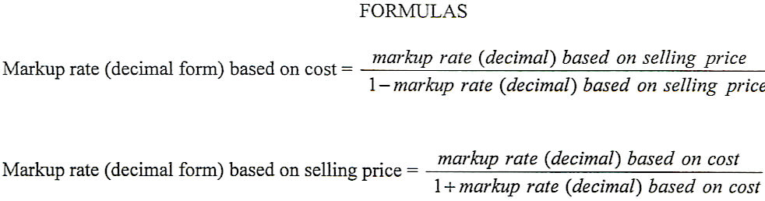

Chapter 7 – This chapter covered basic statistical terms and calculation: mean, median, mode, types of graphs to organize data, as well as range and standard deviation. Try problems:

Exercise Set B: #1-3, 20-22
page 212, #1-2

Chapter 8 – this section deals with net price and trade discount, net amount and cash discounts. Try problems:

Exercise Set B: all

Chapter 9 – this section deals with markups and markdowns. Try problems:

Exercise Set B: all

