Name __________________________________________________
Quiz #3, Fall 2006, College Math I

1. Graph the following points and specify which quadrant they belong to (if any): (1,4), (-2,3), (-2,-5), (4, -1), (-4,0), (0,3), (0,0).
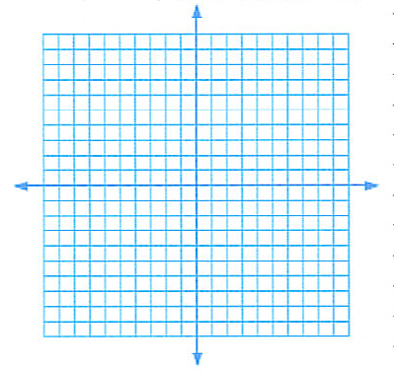
2. Use the graph below to determine the x-intercepts (if any), y-intercepts (if any).
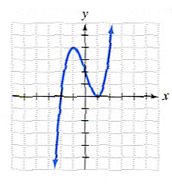
3. Solve the equation for x. $5x−(2x+2)=x+(3x−5)$

Page 2
4. Solve for x. $\frac{4}{x}=\frac{5}{2x}+3$

5. One number exceeds another number by 24. The sum of the numbers is 58. What is the smaller number?

6. What is the definition of the imaginary unit i?

