Name _________________________________________________
Quiz #6/Mid-term Exam, Fall 2006, College Math I

This exam contains 26 problems. Answer 21 of them. Indicate which 21 you wish me to count by circling the problem number. (If you do not, I will grade the first 21.) You will receive some partial credit for attempting problems, so do not leave any selected problems blank.

1. Give the set of numbers $\left\{−\text{11}, \frac{5}{6}, 0, 0\text{.}\overline{\text{142857}}, \sqrt{5}, π, \sqrt{\text{16}}, 2+3i\right\}$, use correct set notation to list the number that belong to the following sets:
a) natural/counting numbers
b) integers
c) rational numbers
d) irrational numbers
e) real numbers
f) complex numbers

2. Write the following in correct scientific notation: $\frac{2\text{.}4×{\text{10}}^{−2}}{4\text{.}8×{\text{10}}^{−8}}$

3. Simplify: ${\left(\frac{4a^{−6}b^{5}}{\text{64}a^{8}b^{3}}\right)}^{12}$

4. Find the product, and indicate the degree of the resulting polynomial: ${\left(5x−3\right)}^{2}$

5. Factor: $x^{3}−x^{2}−5x+5$

6. Simplify: $\frac{x^{2}−4}{x−2}÷\frac{x+2}{4x−8}$

7. Plot the equation $y=\left|x+1\right|−1$ on the graph below, using x = -3, -2, -1, 0, 1, 2, 3.
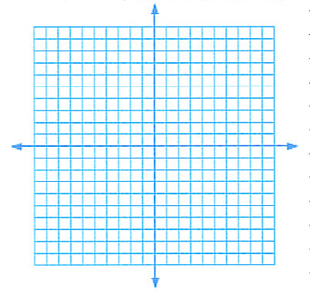

8. Solve the linear equation: $\text{16}=3(x−1)−(x−7)$

9. Solve the rational equation: $\frac{8x}{x+1}=4−\frac{\text{12}}{x+1}$

10. When 60% of a number is added to the number, the result is 192. What is the number?

11. Simplify and write the result in standard form: $(8−4i)(2−7i)$

12. What is the complex conjugate of $3i−6$?

13. Solve the quadratic equation by factoring: $x^{2}−\text{11}x=−4x+\text{44}$

14. Solve the quadratic equation by any means you wish: $4x^{2}−2x−7=0$

15. Solve the radical equation and check all solutions: $\sqrt{x+\text{10}}=x−2$

16. Solve the equation in quadratic form: $(x−5)^{2}−4(x−5)−\text{21}=0$

17. Solve the absolute value equation: $2\left|3x−2\right|=\text{14}$

18. Solve the inequality and draw the solution on the number line below. Write the solution in set builder notation.
$$2x−\text{11}<−3(x+2)$$

19. Evaluate the function for the specified values and simplify: $f(x)=x^{2}+2x+3$
a) f(3) b) f(x-2)

20. Use the graph to determine the following:
a) relative maxima
b) relative minima
intervals (in interval notation) where the function is
c) increasing
d) decreasing

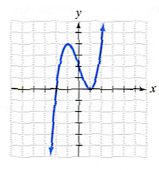

21. Find the slope of the line passing through the points (4, -2) and (3, -1). Does this line go up to the right, or up to the left?

22. Find the equation of the line with slope $−\frac{3}{5}$ and an x-intercept of (3,0).

23. Find the equation of the line perpendicular to the line $y=\frac{4}{5}x−\frac{\text{17}}{5}$ and passing through the point (5,8).

24. The following function $g(x)=\frac{1}{2}\sqrt[3]{x−4}+5$ is derived from the function $f(x)=\sqrt[3]{x}$ by applying three different transformations. Locate each transformation and indicate what it does to the base function (indicate size and direction).

25. Find $\left(f∘g\right)\left(x\right)$ if $f(x)=x^{2}+2$ and $g(x)=\sqrt{x−1}$.

26. Find the distance between the points (-4,-1) and (2,-3). Find the midpoint of the line that connects the points.

