Name _______________________________________________
Exam #1, Math 116, Autumn 2007

1. Consider the following preference table and complete the questions below based on this information.
# of votes | 6 | 11 | 9 | 7 | 3 | 5
1st place | H | R | H | B | R | D
2nd place | D | H | B | D | H | H
3rd place | R | B | D | R | B | B
4th place | B | D | R | H | D | R
a. Find the total number of votes cast.

b. Find the total number of votes needed for a majority.

c. Find the winner of the election according to the Plurality Method.

d. Find the winner of the election according to the Plurality with Elimination Method.

e. Does this election violate the Majority Criterion? Why or why not?

2. Answer the following questions based on the preference table below.
# of votes | 25 | 14 | 18 | 12 | 8 | 4
1st place | A | Q | K | Q | K | A
2nd place | Q | K | A | A | Q | K
3rd place | K | A | Q | K | A | Q
a. Find the winner of the election according to the Borda Count Method.

b. Rank the winners according to the Extended Borda Count Method.

c. Does this election violate the Condorcet Criterion? Why or why not?

3. For each of the graphs below, determine if the graph has an Euler circuit, an Euler path, or neither. For each graph, clearly label all odd vertices.

a. 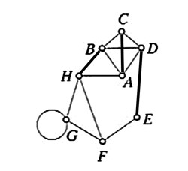 b. 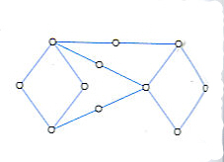

c. 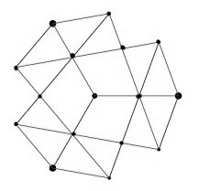 d. 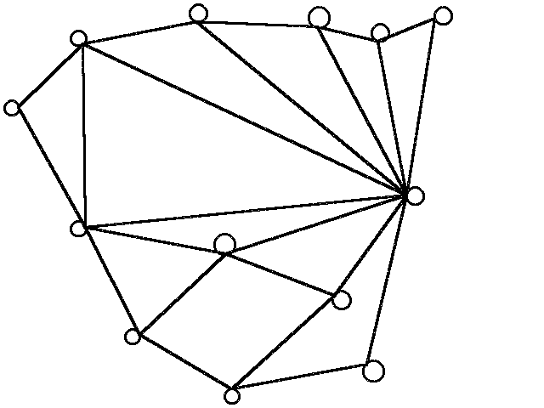

4. Consider the graph below. 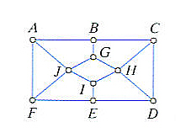
a. Find the number of odd vertices.

b. What is the minimal number of edges you will need to add to Eulerize the graph?

c. Find an Eulerization of the graph, and illustrate the circuit by numbering the edges along your route.
5. Find the number of events that fit the criteria described below.

a. You are asked to create a six-digit passcode using alphanumeric keys (i.e. A-Z, 0-9). Suppose that case does not matter. How many can start with a number and end with a vowel?

b. How many five digit numbers are divisible by 5?

c. In combination or permutation notation (do not find the actual value), how many ways can the fifty US states be ranked top ten in pollution statistics?

6. Nine names (R-Z) are written on slips of paper and put into a hat. Four names are randomly chosen to receive four (non-identical) raffle prizes.

a. How many ways can these names be chosen?

b. What is the probability that X will be chosen first?

c. What is the probability that X will be any of the four names chosen?

d. What are the odds against X being chosen for one of the names?

Vocabulary & Short Answer

7. If the probability of an event E is P(E) = 0.35, what is the probability of the complementary event?

8. Explain the difference when do you use permutations vs. when do you use combinations?

9. What are the conditions that must be satisfied for a graph to have an Euler path?

10. Two edges are said to be this if they share a common vertex.

11. Fleury’s algorithm allows you to find what?

12. What does Arrow’s impossibility theorem say?

13. What are the things you need to check to determine if the Independence of Irrelevant Alternatives is being satisfied or violated?

14. For an election with 16 candidates, how many pairwise comparisons are their to check?

