Name ________________________________________________
Exam #2, Math 116, Autumn 2007

1. For the weighted voting system [q: 65, 35, 30, 25] determine the following:
a. The minimum quota for the system

b. The maximum quota for the system

c. For the case with the minimum quota, determine if there are any
i. dictators

ii. players with veto power

iii. dummies

2. For the weighted voting system [13: 9, 5, 3]
a. Calculate the Banzhaf power distribution

b. Calculate the Shapley-Shubik power distribution

c. What can you conclude from this information about the power of P₃?

3. For the following graphs, determine if a) the graph is complete, b) the graph satisfies Dirac’s theorem, c) if the graph has a Hamilton circuit or path (and if so, find one).

i. 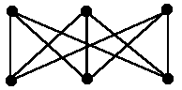 ii. 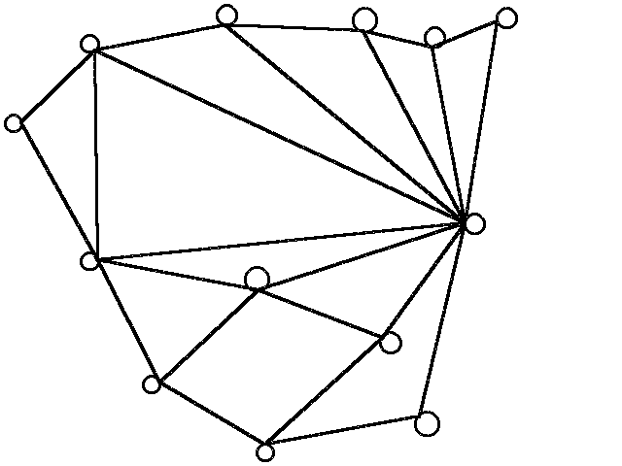

iii. 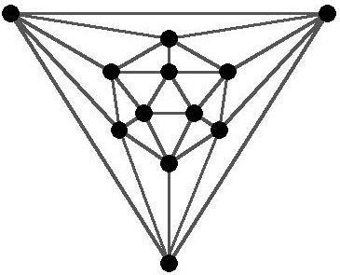 iv. 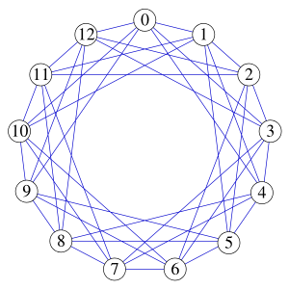

4. Consider the following TSP. Use the Repetitive Nearest Neighbor method to solve the TSP for a routing starting at vertex A.

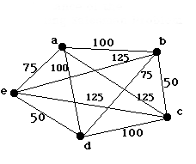

5. Consider the population sequence {5, 9, 13, 17, 21, 25,…}. Find the following:
a. The initial population

b. A recursive formula for the sequence.

c. An explicit formula for the sequence.

d. The value of the 38th transition.

e. The sum of the first 39 terms of the sequence.

6. Suppose that $874.83 is deposited in a savings account that pays 7.75% annual interest compounded weekly.

a. What is the weekly interest on this account?

b. What is the common ratio?

c. Assuming no withdrawals are made, how much money will be in the account after 5 years.

Short Answer & Vocabulary
7. If a weighted voting system has 8 players, what are the total number of coalitions in the system (both winning and losing).

8. If a weighted voting system has 8 players, what are the total number of sequential coalitions needed to calculate the Shapley-Shubik power index?

9. What is a complete graph?
10. Find the total number of unique Hamilton circuits for the graph K₈?

11. What is the difference between an optimal and an efficient algorithm?

12. Describe the steps involved in the Cheapest Link Algorithm.

13. The population sequence generated by an exponential growth model is called a ___________________ sequence.

14. The p-values used in calculating a logistic growth model are percentages of what value?

Bonus:
A population grows according to the logistic growth model with growth constant r = 2.5 and initial population p₀ = 0.3. Find the first ten transitions in the population sequence, and based on that information determine if the population is stable, attracting, periodic or chaotic.

