Name ______________________________ Final Exam, Math 116, Autumn 2007

1. For an election with four candidates (A, B, C, and D) we have the following preference schedule:

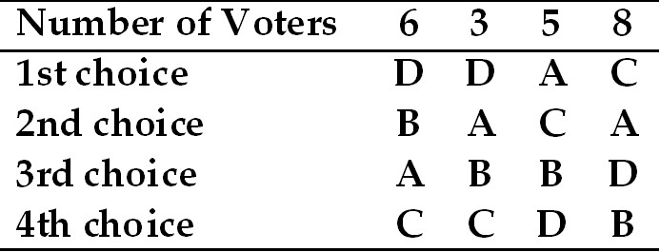

a. How many pairwise comparisons must be made to determine the winner?

b. Who is the winner of the election according to the pairwise comparison method?

c. Rank the remaining candidates using the extended pairwise comparison method.

d. Is the Condorcet candidate and the Majority candidate the same in this election? Why or why not?

2. a. In the weighted voting system 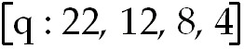, the smallest possible value that the quota q can take is

b. Using the quota of q = 30, who are the
i. Dictators?

ii. With veto power?

iii. Dummies?

c. Find the Banzhaf power distribution for the system with q = 30.

d. Does your answer in c match your answer in b? How? Why or why not?

3. A small country consists of four states. The population of State A is 44,800, the population of State B is 52,200, the population of State C is 49,200, and the population of State D is 53,800. The total number of seats in the legislature is 100.

a. If we wished to calculate the apportionment of seats in the legislature according to Jefferson’s method, which of the following divisors is most likely to work? 1950? 2005? 2040?

b. Use the modified divisor above to calculate the apportionment for Adam’s method.

c. Is there a quota violation for this apportionment?

4. Consider a country whose populations in the years 2005 and 2006 are given in the table below.

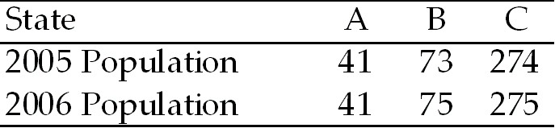

Using Hamilton's with M = 25 seats yields the apportionments shown in the following table

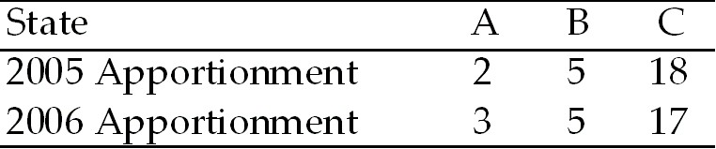

a. Does this data represent a paradox? Is so, which one?

b. Explain why this situation is paradoxical. Indicate in the tables above which elements in the table lead you to this conclusion. You may need to support you explanation with calculations.

5. Use the figure below to answer the following question(s).

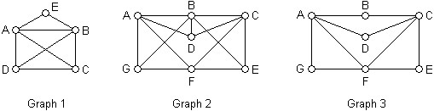

a. Which of the graphs has a unicursal tracing? If so, is it open or closed?

b. Which of the graphs has a Hamilton circuit?

c. Find a spanning tree for each graph.

d. For Graph 2, which edges need to be duplicated to eulerize the graph?

6. a. A complete graph is defined as

b. For a graph 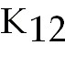, how many edges are in the graph?

c. For a graph , how many Hamilton circuits can be found?

d. How many spanning trees does the following graph have?

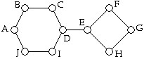

7. a. Use Kruskal’s Algorithm to find the minimal spanning tree for the following weighted network. Label the spanning tree on the graph and state the weight.
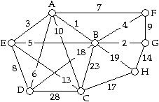

b. Kruskal’s Algorithm approximate, optimal or efficient? Explain.

c. Which TSP algorithm is Kruskal’s most like? Explain how they differ.

8. a. What is the difference between an interior junction and a native one?

b. What is the length of the shortest network connecting points A, B, and C shown in the following map?

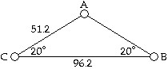

c. Three points X, Y, and Z lie inside a triangle ABC. Based on the chart given below, which of these is a Steiner point?

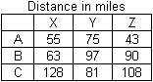

d. What is the number of Steiner points connecting any three vertices?

e. What is the degree of every Steiner point?

9. a. Given a population of rabbits in a confined habitat with a carrying capacity of 10,000 rabbits and an initial population of 2400. If the population varies according to a logistic population model, what is the initial population p₀?

b. If the growth parameter for the population is 1.6, find p₁ through p₁₀ of the population sequence.

c. Is the population stable, attracting, periodic or chaotic?

10. a. What is the probability that a random person on the street was born on a Tuesday?

b. If a person is born in February (during a non-leap year), what is the probability they will be born on a Tuesday?

c. If you are born in February (during a non-leap year), what are the ODDS against being born on a Tuesday?

d. What are the ODDS for being born on a weekend?

