Name ____________________________________________________
Quiz #3, Math 116, Autumn 2007

1. Determine if the following graph has a unicursal tracing. If so, what kind is it? Choose a starting point and number the edges as you trace them.
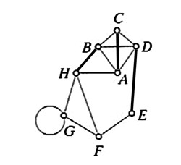

2. a. What are the conditions that must be satisfied to find an Euler circuit on a graph?

b. What is an isolated vertex?

c. Define a bridge.

3. Find an Eulerization of the graph below. What are the minimal number of edges you will need to add (not necessarily the number you actually added)?
