Name ____________________________________________________
Quiz #3, Math 116, Autumn 2007

1. Determine if the following graph has a unicursal tracing. If so, what kind is it? Choose a starting point and number the edges as you trace them.
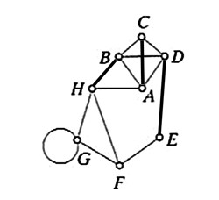
It does; it’s an Euler path since both C & F are odd. Answers will vary.

2. a. What are the conditions that must be satisfied to find an Euler circuit on a graph?
1) graph is connected, 2) all vertices must be even.

b. What is an isolated vertex?
An isolated vertex is not connected by an edge to any other vertex.

c. Define a bridge.
A bridge is an edge that if removed will cause the graph to become disconnected.

3. Find an Eulerization of the graph below. What are the minimal number of edges you will need to add (not necessarily the number you actually added)?
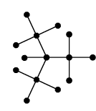
theoretically, you’ll have to add at least 5, but you will have to duplicate every edge.

