Name _____________________________________________
Quiz #7, Math 116, Autumn 2007

1. Explain the difference between a Hamilton circuit and an Euler circuit. AND give an example of each.

An Euler circuit must touch every edge once and only once. Vertices may be visited more than once.
A Hamilton circuit must touch every vertex once and only once. Edges may be skipped.
Examples may vary.

2. a. Find a Hamilton circuit (or path) on the following graph, if one exists. Label the edges used clearly.
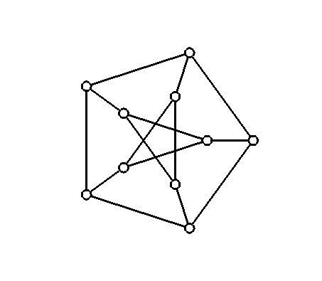
b. Determine if the graph satisfies Dirac’s theorem. NO

c. In order to make a complete graph with the same number of vertices, how many edges would be needed?
45

3. For the following graph, use the Nearest Neighbor Algorithm to find a solution to the TSP starting at vertex C. Give the circuit. What is the weight of the final graph?
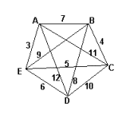 CBAEDC, 30

