Name ________________________________________________
Quiz #8, Math 116, Autumn 2007

1. Consider a population that decays according to a linear model. The initial population is P₀ = 547, and the common difference is d = -13.
a. Find P₂₄ 235

b. How many generations will the population take to become extinct?
43

2. Crime in Happyville is on the rise. Each year the number of crimes committed increases by 50%. Assume that there were 200 crimes committed in 2000 and let P_{N} denote the number of crimes committed N years after 2000.
a. Give a recursive description of P_{N} P_{N} = P_{N-1}*1.5

b. Give an explicit description of P_{N} P_{N} = P₀*1.5^{N}

c. If the trend continues, approximately how many crimes will be committed in Happyville in the year 2012? 25,949

3. A population grows according to the logistic growth model, with growth parameter r = 1.8. Starting with an initial population given by p₀ = 0.4.
a. Find the values p₁ through p₁₀ .432, .4416, .4439, .4443, .44442, .44444, .444443, .4444443, .44444441, .44444444…

b. is the population stable, attracting, periodic or chaotic? Attracting/stable

4. Solve the TSP graph below using the Cheapest Link Algorithm. State the final circuit starting from vertex D, and its weight.
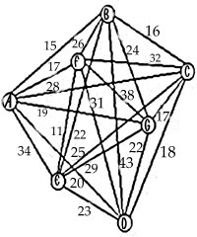DEFABCGD = 121

