MATH 102 Final Exam Review

Directions: Some of the questions on this review may require the use of the graphing calculator; others may require you to show all work. If an algebraic answer is required and work is not shown, you may not receive full credit on the final exam. On the final exam you must show work in the spaces provided and show graphs on the grids provided. Partial credit may be awarded on most problems. Reduce fractions to lowest terms. The final exam counts as 40% of your overall grade and contains 200 possible points. You will have 1 hour and 50 minutes to complete the final exam, but this review will most likely take you at least twice as long to complete.

- Given the following set of real numbers:
List the numbers that are: a) rational b) irrational c) integers

- Graph the following real numbers on a number line: 3.14, 3.2, , π

- Graph the following on a number line and then describe the graph with interval notation.
a) b)

- Perform the indicated operations algebraically. Verify your result using your calculator.
a) $−3^{2}+6{\left(−1\right)}^{4}$ b) $6−5{\left(5−3\right)}^{2}$ c)

- Use your calculator to evaluate $\frac{\sqrt{\text{63},\text{876}}+\text{14}}{3\left(\text{77}\right)}$. Round answer to the nearest hundredth.

6. a) Insert parentheses into the expression below so that it is equivalent to
- b + b ² - 4 a c / 2 a

b) Given a = 2.14, b = -5.2, and c = 1.781, the value of the expression above is __________ , rounded to
the nearest hundredth.

7. Evaluate $\frac{{\left(4p+q\right)}^{2}}{2p+q}$ for p = 5 and q = -4. Express the answer as a fraction.

- Use the commutative and associative properties to simplify the given expression.
a) b) $x+\left[7+\left(−x\right)\right]$

- Is x = 0 a solution to $3x−\text{12}=−3\left(4−x\right)$? Defend your answer.

- Simplify $6+4\left[−2\left(5−3x\right)−\left(5x−3\right)\right]$.

- Translate the verbal description into an algebraic expression:
- The perimeter of a rectangle whose width is half its length L.
- The sales tax on an item with a price of d dollars if the tax rate is 8%.

- The surface area of a right circular cylinder, which has a top and a bottom, is given by the formula where r is the radius of cylinder and h is the height of the cylinder.

- What is the surface area of the cylinder if the radius is 2.7 meters and the height is 11.3 meters?
Round your answer to the nearest hundredth.
- Solve the formula for h.
- What is the height of the cylinder if the surface area is 890 ft² and the radius is 7 feet? Round your answer to the nearest hundredth.

13. Solve the equations: a) $−2\left(x+5\right)=5\left(1−x\right)+4\left(7−x\right)$ b)

c) d) $4−8x+\text{10}=−2\left(4x−7\right)$

14. Solve the formula $C=\frac{5}{9}\left(F−\text{32}\right)$ for F.

- Recall the compound interest formula: $A=P{\left(1+\frac{r}{n}\right)}^{\text{nt}}$ Find the amount of money in the account if $600 is invested at 8.5% for 11 years and the interest is compounded as follows: a) quarterly b) daily
Round your answers to the nearest cent.

Solve problems 16–18 using an equation. Define a variable (x = ?), write an equation that could be used to solve the problem, then solve the equation and state the solution precisely.

- The width of a rectangle is 8 feet less than the length. If the perimeter of the rectangle is 64 feet, what are the dimensions of the rectangle?

- A 45-foot rope is to be cut into three pieces. The second piece must be twice as long as the first piece
and the third piece must be 9 feet longer than three times the length of the second piece. How long should
each of the three pieces be?

- A salesperson earns a base salary of $575 per month plus 24% of all sales. Find the amount a salesperson would need to sell in order to earn $1050 for one month.

- The cost C of producing x number of cassette tapes is given by . Income R from the sale of these tapes is given by . Find how many tapes must be sold to break even.

- Suppose Harry receives a 5% increase in his weekly salary. If his weekly salary after the increase is $475, what was his old salary before the increase?

- John has a job watering and tending gardens for people who are on vacation. He charges $6.25 per hour per 100 ft² for gardens that are mostly vegetables and $8.25 per hour per 100 ft² for gardens that are mostly flowers. His price increases in 15-minute intervals with a 1-hour minimum.

- Complete the following table for the costs of jobs (per 100 ft²) ranging from 1 to 3 hours.

Hours | 1 | 1.25 | 1.5 | 1.75 | 2 | 2.25 | 2.5 | 2.75 | 3
Mostly Vegetables
Mostly Flowers

- If a job that consists of tending a 100 ft² vegetable garden takes John 8 hours, how much does he charge?

- List four solutions to the equation .

- Write the equation in slope-intercept form. Then determine the slope and y-intercept.

- a) Write the equation of a horizontal line that passes through the point (5, 3).
b) Write the equation of a vertical line that passes through the point (5, 3).

- A line with no slope, or undefined slope, is different from a line with zero slope. Explain the difference.

- Use the concept of slope to explain the difference between parallel and perpendicular lines.

- Determine the intercepts of .

- Draw a line that contains the point (-4, 6) and has a slope of –8.

- Given the following equations: a) b) c) d)
i) Identify the shape of each graph from the equation. ii) Graph each equation.

- Broyhill Furniture found that it takes 2 hours to manufacture each table for one of its special dining room sets. Each chair takes 3 hours to manufacture. A total of 1500 hours is available to produce tables and chairs of this style. The linear equation that models this situation is , where x represents the number of tables produced and y the number of chairs produced.

- Complete the ordered pair solution (0, ) of this equation. Describe the manufacturing situation that this solution corresponds to.

- Complete the ordered pair solution ( , 0) for this equation. Describe the manufacturing situation that this solution corresponds to.

- If 50 tables are produced, find the greatest number of chairs the company can make.

- The equation models the weekly salary, S, of a salesperson who sells a total of p dollars of hardware each week. Both p and S are given in dollars.

- Interpret the meaning of the ordered pair (1000, 400).

- If the salesperson sells a total of $2350 of hardware in a week, what will their salary be?

- A salesperson’s salary was $750 this week. How much hardware did they sell?

- Graph the equation on a coordinate grid, using paper and pencil.

- State a viewing window that would enable you to see a complete picture of this graph on your calculator.

- Write an equation of a line that passes through (4, -8) and (-4, -2). Write answer in slope-intercept form.

33. Write the answers to the following in slope-intercept form:

- Write an equation of a line containing (-2, -3) and parallel to the line .

- Write an equation of a line containing (-2, -3) and perpendicular to the line .

34. The deposits at Etowah Bank in Georgia grew from $130 million in 1993 to $195 million in 1997. Assume
a linear relation where x is the number of years since 1993 and write an equation for deposits in any year.
Use the equation to predict the deposits in the bank in 2004.

35. Let . Find the following values: a) f(0) b) f(-5) c) f(7.25)

36. Evaluate to find the exact value of T(-2.5).
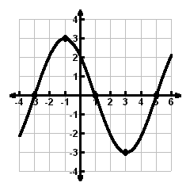
37. Given the graph of f(x), answer the following:

- f(1) =

b) f(3) =

c) f(-3) =

d) f(-1) =

e) If f(x) = 0, then x = ________

38. State the domain and range of the graphs below. Write your answers using interval notation. Determine
if each graph is a function or not. Justify your answer, using the definition of a function in your response.
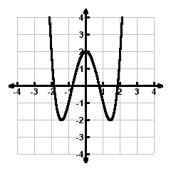
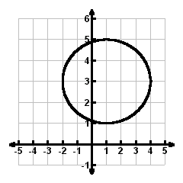
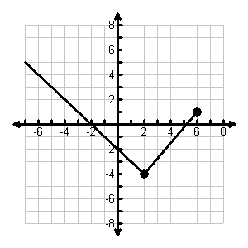

- b) c)

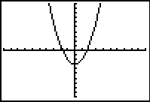
39. Given the graph of the equation: y = x² – 3
as illustrated by the TI-84 view screen,
state the domain and range using interval notation.
Also, determine if the graph represents a function.

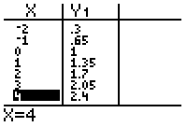
40. Use the given table for some function f(x) to answer
the following questions:
- f(-1) =
b) f(x) = 1, then x = ?
c) If f(x) is a linear function, find the slope.
d) Find the equation for f(x).
41. Complete the ordered pairs in order to meet the condition stated.
a) Set A is a Function: A = $\left\{ (1, 3), (3, 1), (5, 7), (\text{?,} ?) \right\}$
b) Set B is NOT a Function: B = $\left\{ (1, 3), (3, 1), (5, 7), (\text{?,} ?) \right\}$

42. The average top ticket price for Broadway plays increased dramatically between 1975 and 2003.

Year | 1975 | 1985 | 1998 | 2000 | 2003
Average Ticket Price | 10.76 | 35.29 | 56.35 | 91.35 | 100.05

a) Using the data in the table, find the regression equation that best fits the data. (Let x = 0 represent the
number of years since 1970.) Express decimals rounded to three digits.

b) Predict the average top ticket price for Broadway plays in the year 2013 if the prices continue to
increase at the same rate.

c) Find the rate at which the cost is rising, rounded to the nearest cent.

43. Solve $−πx+1\text{.}2=0\text{.}3\left(x−5\right)$ graphically on your calculator using the intersection method. Round your
solution to the nearest hundredth.

44. Solve the following linear inequalities. Express answers using interval notation.

a) $−\text{12}\left(x−5\right)−\text{50}≥\text{15}$ b)

