MATH 102 Final Exam Review Key

1. a) b) $\left\{ π, \sqrt{3} \right\}$ c)

2.
3.14 $π$ 3.2 $\frac{\text{10}}{3}$

3. a) (– 2, 5] b) (– ∞, 7]

–2 5 – ∞ 7

4. a) -3 b) -14 c) 5. 1.15

6. a) (- b + ( b ² - 4 a c ) ) / ( 2 a ) b) 2.02

7. 8. a) xy b) 7

- Yes, substitute 0 for each x and see that the two sides are equivalent.

- 4x – 22 11. a) perimeter is 3L b) sales tax is 0.08d

12. a) 237.50 m² b) c) 13.24 feet

13. a) b) c) no solution d) all real numbers

14. or

15. a) $1513.43 b) $1528.16 16. length = 20 feet, width = 12 feet

17. 4 ft., 8 ft., and 33 ft. 18. $1979.17 in sales

19. 1059 cassette tapes 20. old salary was $452.38

21. a)
Hours | 1 | 1.25 | 1.5 | 1.75 | 2 | 2.25 | 2.5 | 2.75 | 3
Mostly Vegetables | 6.25 | 7.81 | 9.38 | 10.94 | 12.50 | 14.06 | 15.63 | 17.19 | 18.75
Mostly Flowers | 8.25 | 10.31 | 12.38 | 14.44 | 16.50 | 18.56 | 20.63 | 22.69 | 24.75

b) $50

22. Answers will vary. (–5, – 4), (0, – 2), (5, 0), (10, 2) are four possible solutions.

23. $y=−\frac{5}{4}x+\frac{\text{40}}{3}$; slope = $−\frac{5}{4}$; y-intercept point = $\left(0, \frac{\text{40}}{3}\right)$

24. a) y = 3 b) x = 5

25. A line with no slope is a vertical line (the slope is undefined and does not exist).
A line with zero slope is horizontal.

26. Parallel lines have the same slope and perpendicular lines have slopes which are negative reciprocals.

27. y-intercept point = (0, 4); x-intercept point = (-2, 0)

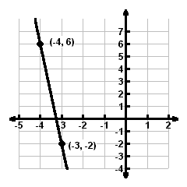
28.

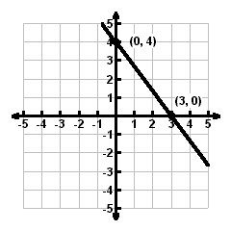
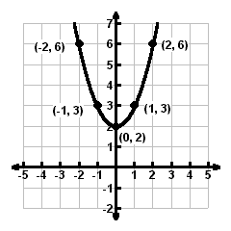
29. a) line b) parabola

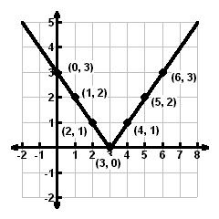
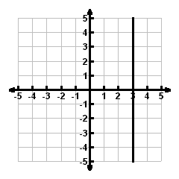
c) v-shaped d) line

30. a) (0, 500); 0 tables and 500 chairs could be manufactured in the available 1500 hours.
- (750, 0); 750 tables and 0 chairs could be manufactured in the available 1500 hours.
- If 50 tables are produced, then 466 chairs could be also be produced in the available 1500 hours

31. a) If a salesperson sells $1000 of hardware in a week, then they will have a weekly salary of $400.
- $535
c) $4500
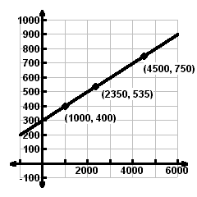
d)

e) [-1000, 6000, 1000] by [-100, 1000, 100] is one possible window

32. $y=−\frac{3}{4}x−5$ 33. a) $y=−\frac{2}{3}x−\frac{\text{13}}{3}$ b) $y=\frac{3}{2}x$

34. $y=\frac{\text{65}}{4}x+\text{130}$ where x is the number of years since 1993 and y is the deposits in millions of dollars;
$308.75 million

35. a) 0 b) -45 c) -23.56 36.
37. a) 0 b) -3 c) 0 d) 3 e) -3, 1, and 5

38. a) domain = $\left(−∞, ∞\right)$, range = , function (explanation may vary)
- domain = [-2, 4], range = [1, 5], not a function (explanation may vary)
- domain = $(−∞, 6]$, range = $[−4, ∞)$, function (explanation may vary)

39. domain = (– ∞, ∞), range = [– 3, ∞), function (explanation may vary)

40. a) 0.65 b) 0 c) 0.35 d) f(x) = 0.35x + 1

41. a) Answers will vary…use any x-coordinate except 1, 3, or 5. The y-coordinate can be anything.
- Answers will vary…the x-coordinate must be a 1, 3, or 5. The y-coordinate can be anything as long as the ordered pair you write is not already in the list.

42. a) y = 3.008x – 8.012
b) The predicted average top ticket price for 2013 is $121.32 per ticket.
c) The cost per ticket is increasing $3.01 per year.

43. x = 0.78 (Do not write the y-coordinate.)

44. a) b) $\left(−∞, −\frac{\text{18}}{\text{17}}\right)$

