Using The TI-83/84 for Quadratic Regression
(Textbook Section 8.7)

You can use the TI-83/84 calculator to determine the correlation between two variables, calculate & graph the quadratic regression equation, and use the equation to predict other y-values. There are four big “steps” to do this.

STEP 1: Enter the data into lists

Press the STAT key and then select 1: Edit. You will now see the data screen with six possible lists, L₁ through L₆.

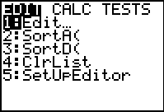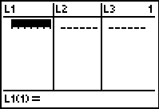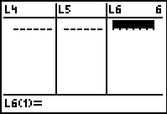

If there is already data in any of the lists, you need to clear the lists. Do this by placing your cursor at the top of the list you wish to clear and then hit the CLEAR and ENTER buttons. Do not hit the DEL button; this will delete the list from your calculator.

Another way to clear a list is to press the STAT key, then select 4: ClrList, then type in the list you want cleared (2ND key and 1 key for list L₁) and finally, press ENTER.

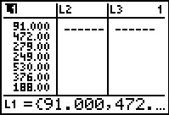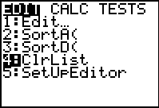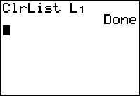

We are now ready to enter the data into the lists. Let’s enter the numbers:

1 2 3 4 5 6 (x-values)
18 12 9 7 8 10 (y-values)

(It is common practice to enter the first list of numbers (x-values) into L₁ and the second list of numbers (y-values) into L₂.)

Press ENTER after each number, and use the arrow keys to move between L₁ and L₂. To correct a data entry, highlight the entry that is wrong and enter the correct data value. To delete a data entry, highlight the data value you wish to delete and press the DEL key. To insert a new entry into a list, highlight the position directly below the place you wish to insert the new value and then press 2nd INS and then enter the data value. Once completed, your lists should look like this:

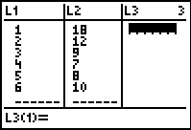

STEP 2: Plot the data points

To construct a scatter plot of the points, press 2nd STAT PLOT (above Y=). Highlight 1: Plot1 and press ENTER. Then on the next screen select On (put cursor on On and hit ENTER) and the scatter plot (first graph on the first row). Set Xlist to L₁ and set Ylist to L₂. Set your mark for each point by selecting a box, cross, or dot.

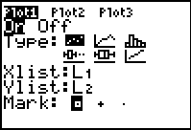
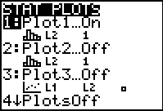

Next press ZOOM 9 (ZoomStat) to set the graphing window and see the scatter plot. You can also use the WINDOW button to set your window, but ZOOM 9 is easier.

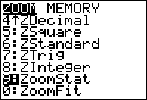
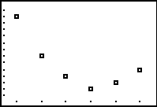

STEP 3: Find the regression equation

To leave the data screen, press 2nd QUIT. Hit Y= and clear out any pre-existing equations.
Hit STAT and arrow over to the CALC menu and then down to 5: QuadReg and press ENTER so that command comes up on your screen. When you hit ENTER again the equation is displayed (second screen):

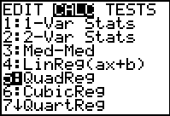
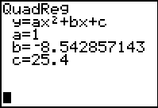

From the screen above, you see that the quadratic regression equation is y ≈ x² – 8.543x + 25.4
To paste the regression equation into the Y= repeat the process above (STAT, CALC, option 5) but do not hit ENTER to compute the equation values yet….
Instead, press VARS, arrow over to Y-VARS, select 1: Function, and finally select Y₁. Right now, your screen should look like this:
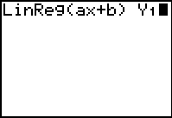

Now, hit ENTER again. The regression equation will be displayed like before, but the equation should also be pasted in your Y= screen! If you press GRAPH you will now see the scatter plot with the regression equation.
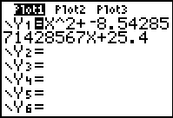
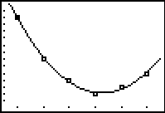

STEP 4: Predict other y-values on the graph

To predict other y-values on the graph, you can either enter the x-value into the regression equation and calculate an estimate for y algebraically, or you can use the calculator to do the same thing. To use the calculator, press 2nd CALC (above the TRACE key) and select 1: value and press ENTER. A cursor will appear and this will allow you to enter a value for x to find its corresponding y-value. For example, to predict the corresponding y-value for an x-value of 3.5, type 3.5 and press ENTER again. You will now see that Y = 7.75.

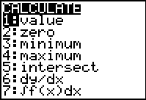
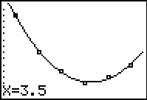
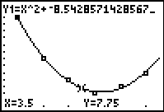

To predict y-values that are not somewhere on the portion of the graph currently displayed in the ZoomStat window, you will need to change the window settings manually. For example, let’s predict the y-value when x = 10.
First, change the window settings to allow “room” for this x-value; let Xmax = 11. Then, press 2nd CALC (above the TRACE key) and select 1: value and press ENTER. Then, type 10 and press ENTER again.
You will now see that Y ≈ 39.97.

