
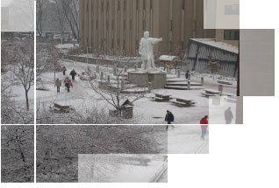
Severe Weather Policy
In the event that Columbus State must close or alter its operating schedule because of severe winter weather or other emergencies, an announcement will be broadcast on the following television and radio stations:
Televisions Stations
• WBNS-TV (10) | • WCMH-TV (4) | • WSYX-TV (6) | • WSYX-TV (28)

Radio Stations
• WTVN-AM | • WVKO-AM | • WCKX-FM | • WHOK-FM | • WNCI-FM
• WCVO-FM | • WSNY-FM | WUFM-FM | • WCEZ-FM | • WWCD-FM
• WCOL-FM | • WLVQ-FM | • WRVF-FM | • WAZU-FM | • WCBE-FM
• WMNI-AM | • WOSU-AM/FM | • WBNS-AM/FM | • WXMG-FM | • WVCO-AM
• WZNW-FM | • WFJX-AM | • WSMZ-FM | •WYJD-FM
Students who reside in areas which fall under a Level III Weather Emergency should not attempt to drive to Columbus State even if the college remains open. Consult your course syllabus for information on the makeup of missed laboratories and clinicals. It is the student's responsibility to keep up with reading and other assignments when a scheduled class does not meet, whatever the reason.
Scheduled Class Work
If an assignment is due on the day the college is closed, or the class is canceled, the assignment will be collected at the next scheduled class period. If an examination is scheduled for a day the campus is closed, or the class is canceled, the examination will be given on the next scheduled class day. If a laboratory is scheduled on a day the campus is closed, it will be made up at the next scheduled laboratory class. In the event the college is forced to close during Final Examination Week, daytime exams scheduled for the first missed date will be rescheduled for Friday of Exams Week, in the same location and at the same time as scheduled.
Extended Closure
If the college remains closed for a second day, the daytime exams scheduled for that day will be given on Saturday of Exams Week at the same time and place. Exams scheduled for additional dates during Finals Week that are missed will be scheduled for another date that will be announced to all students. See the college’s Final Exam schedule posted on the Academic Calendar page of this website (http://www.cscc.edu/docs/calen/calendar.htm).

