Math 130

Inverse Function Supplement

Recall that one can combine two given functions under the operation of composition and the result is a new function.
1. Given $f\left(x\right)=3x−2$ and $g\left(x\right)=\frac{x+2}{3}$ find both compositions.
$\left(f∘g\right)\left(x\right)=$ $\left(g∘f\right)\left(x\right)=$

2. Given $f\left(x\right)=x^{3}+5$ and $g\left(x\right)=\sqrt[3]{x−5}$ find both compositions.

$\left(f∘g\right)\left(x\right)=$ $\left(g∘f\right)\left(x\right)=$

3. While composition of functions is not necessarily commutative notice that for the two
pairs of functions in problems 1 and 2 $\left(f∘g\right)$ and $\left(g∘f\right)$ both had the same result - and
furthermore they both equal $x\text{.}$ In each problem you have discovered a pair of inverse
functions!

Consider another function $f\left(x\right)=x+5\text{.}$ Let the domain of $f$ be $\left\{−7,−3,0,9,\text{16}\right\}$.
Complete the mapping to show what each member of the domain will map into under
function $f\left(x\right)\text{.}$Recall the the set of results is called the range.

$f\left(x\right)=x+5$

domain of $f$ range of $f$

-7
0
9
-3
16
-2

4. Now find another function $g\left(x\right)$ which allows you reverse your path and begin in the
range of $f$ and return to the domain of $f$. Write the function $g\left(x\right)$ formula in the blank
below the mapping. Add labels in the blanks to each set of numbers in terms of the new
function $g$.

$f\left(x\right)=x+5$

domain of $f$ range of $f$

-7 -2
0 5
9 14
-3 2
16 21

_________ of $g$ __________ of $g$

$g\left(x\right)=\text{____________}$

As functions $f$and $g$ reverse each other and are inverse functions we can indicate the
relationship by renaming $g\left(x\right)$ as $f^{−1}\left(x\right)$. (Or we could call $f\left(x\right)=g^{−1}\left(x\right)!$)

5. Using problem 4 write the five ordered pairs for $f\left(x\right)\text{.}$ The first one is done for you.

$\left(−7,−2\right)$

Now write the five ordered pairs for $g\left(x\right)=f^{−1}\left(x\right)\text{.}$ Remember to start with the domain
of $f^{−1}\left(x\right)\text{.}$

In general notice that for any point $\left(t,v\right)$ on the graph of a function, you will find the
point ______ on the graph of its inverse.

6. Given the graph of a function $f\left(x\right)\text{.}$ On the same grid add the graph of $f^{−1}\left(x\right)\text{.}$
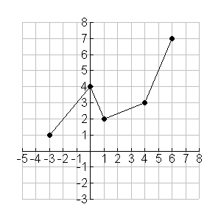
7. At this point you may have discovered if you ‘switch’ the domain x and range y of a function
you will have the inverse of that function.

a) Name the inverse of each of the function given. $\left\{\left(5,3\right),\left(−3,2\right),\left(0,9\right),\left(−4,7\right)\right\}$

b) Graph the inverse of $f\left(x\right)$whose graph is given.
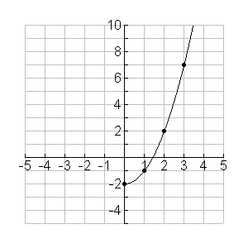
Can you write the expression for$f^{−1}\left(x\right)$
given $f\left(x\right)=x^{2}−2$ for $x≥0\text{.}$

$f^{−1}\left(x\right)=\text{______________}$

8. You are already familiar with the exponential function $f\left(x\right)=2^{x}$ and its graph which is
given for you. Highlight five exact ordered pairs of$f\left(x\right)=2^{x}$on its graph and use them
to help you graph $f^{−1}\left(x\right)$on the same set of axes.
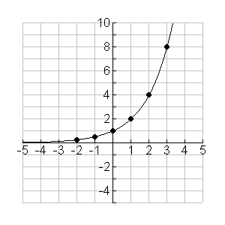
9. Another exponential function we have studied is the natural exponential function $f\left(x\right)=e^{x}\text{.}$
Use the set of axes provided to sketch $f\left(x\right)=e^{x}$ and also graph $f^{−1}\left(x\right)\text{.}$
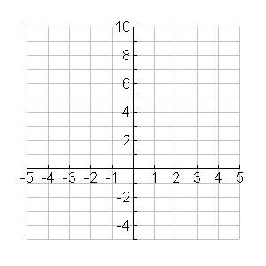
10. SNEAK PREVIEW FOR TOMORROW!
Can you write the expressions for $f^{−1}\left(x\right)$ in problems 8 and 9?

