MATH 103 Final Exam Review SU’11

Directions: Some of the questions on this exam may require the use of the graphing calculator; others may require you to show all work. If an algebraic answer is required and work is not shown, you may not receive full credit on the final exam. On the final exam you must show work in the spaces provided and show graphs on the grids provided. Partial credit may be awarded on most problems. Reduce fractions to lowest terms. The final exam counts as 40% of your overall grade and contains 200 possible points. You will have 1 hour and 50 minutes to complete the final exam, but this review will most likely take you at least twice as long to complete.

1. Complete the ordered pairs in order to meet the condition stated.
a) Set A is a Function: A =
b) Set B is NOT a Function: B =

- State the domain and range of the graphs below. Determine if each graph is a function or not. Justify your answer, using the definition of a function in your response.
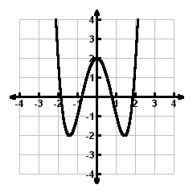
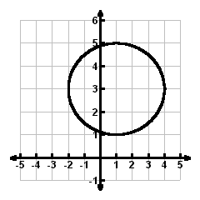
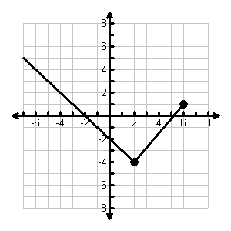
a) b) c)

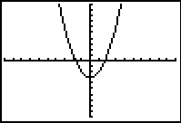
3. Given the graph of the equation: as illustrated by the TI-84 view screen, state the domain and range using interval notation. Also, determine if the graph represents a function.

4. Let . Find the following values: a) f(0) b) f(–5) c) f(7.25)

5. Evaluate to find the value of T(–2.5).
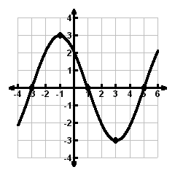
6. Given the graph of f(x), answer the following:

a) f(1) = b) f(3) =

c) f(–3) = d) f(–1) =

- If f(x) = 0, then x = _______

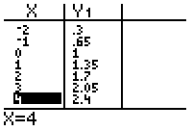
7. Use the given table for some function f(x) to answer
the following questions:
- f(–1) =
b) f(x) = 1, then x = ?

8. Solve the system of equations by the graphing method. Include a graph with the solution
clearly marked. The graph should contain a scale on each axis.

9. Use your calculator to find the solution to the system of equations. Express your answer rounded to two decimal places.

10. Solve the system of equations below using both the substitution and the elimination methods.

a) b)

11. Describe the three possible graphical representations of a linear system of two equations in two variables, and specify the number of solutions contained in each graphical representation.

12. When using the elimination method to solve a linear system of equations, explain how we know when the system is: a) inconsistent b) dependent

Solve problems 13 – 15 using a system of equations. Define each variable (x = ?, y = ?), write a system of equations that could be used to solve the problem, solve, and state the solutions precisely.

13. James has available a 10% alcohol solution and a 60% alcohol solution. Find how many liters of each solution he should mix to make 50 liters of a 40% alcohol solution.

14. A hardware store stocks two types of hammers. The store has a total of 42 hammers, with sledge hammers selling at $22.95 each and claw hammers selling at $10.95 each. If the total value of the hammers is $639.90, how many of each type are in stock?

15. Hertz car rental agency charges $50 daily plus 10 cents per mile. Budget charges $20 daily plus 25 cents per mile. Find the daily mileage for which the Budget charge for the day is the same as that of the Hertz charge for the day.

16. Simplify the following and express the result with positive exponents:
a) b) c) d) e)

17. Simplify . State the degree of your answer.

18. Find each product:

a) b) c) d) e)

19. Divide:

20. Divide:

21. Divide:

22. When the calculator displays the result 3.234E–35, what number is being indicated? (i.e., how would you write the number on paper without listing all the zeros?)

23. Write 31,000,000,000 in scientific notation.

24. Write in standard notation, without exponents.

25. Perform indicated operations. Write the result in scientific notation. Use a calculator to check the result.

26. Factor completely:

a) b) c) d)

e) f) g) h)

i) j)

27. Solve each equation algebraically:

a) b) c) d)

28. An object is dropped off the top of a building that is 256 feet high. The distance, in feet, above the ground at x seconds is given by . Determine when the object hits the ground. Solve this problem both algebraically and using your calculator.

29. The shorter leg of a right triangle is 3 centimeters less than the other leg. Find the length of the two legs if the hypotenuse is 15 centimeters.

30. Determine the value(s) of the variable for which the expression is undefined:

a) b) c) d)

31. Perform the indicated operation:

32. Perform the indicated operation:

33. Perform the indicated operation:

34. Perform the indicated operation:

35. Simplify the complex fraction:

