Math 103 – Beginning Algebra II
Review of Graphing Linear Equations in Two Variables

- Draw a circle around the letter of each equation that is a linear equation in two variables.

- x + 2y = 7 c. 2a + 3b = 9c

- y = x² d.

- Find an ordered pair that satisfies the equation -3x + 2y = 15 __________
by letting x = -3.

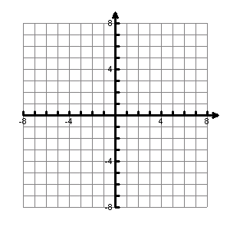
- Graph the equation y = 2x – 3 by plotting points.

x | y

- Solve each equation for y.

  - 2x + y = 4 ______________

  - -3x + 2y = -6 ______________

- Your favorite car-rental agency quotes you the cost of renting a car in Washington, D.C., as $30 per day plus $0.20 per mile. The linear equation models the daily cost, where C represents total daily cost and m represents the number of miles that were driven.
m | C
0
100
200
  - Complete the table to the right.

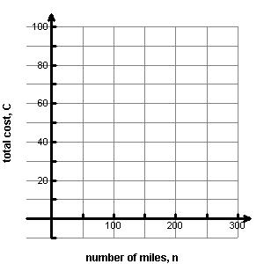
  - Graph the linear equation using the points obtained in part (a).

  - Interpret the meaning of the ordered pair (140, 28) in the context of this problem.

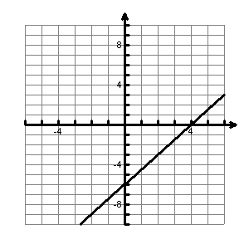
- From the graph, tell the x- and y-intercept
of the graph.

x-intercept __________

y-intercept __________

- Algebraically find the x-intercept and the y-intercept of the linear equation
-3x + 5y = 15. Then graph the linear equation in the coordinate plane.

x-intercept __________

y-intercept __________
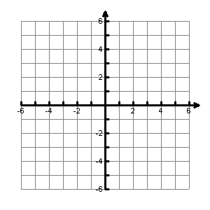

- Find the slope of each line shown in the coordinate plane.
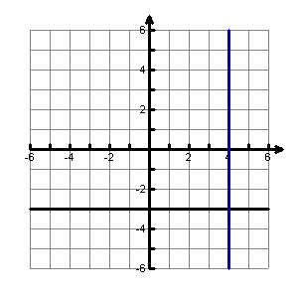
line 1
slope of line 1 _________

slope of line 2 ________

line 2

- Find the slope of the line joining the points (-1, 3) and (2, -2). _________

- Tell the slope of the line . _________
- Tell the y-intercept of the line . _________

- Graph the line using your answers from numbers 10 and 11.

Adapted from Sullivan/Struve Elementary Algebra, 2007

