MATH 103
Class Activity – Solving Polynomial Equations
(Accompanies Section 5.8)

PART I – Quadratic Equations

- A quadratic equation is an equation that can be written in the form
ax² + bx + c = 0. That is, a quadratic equation is a second degree polynomial equation. The form ax² + bx + c = 0 is called standard form.

Examples of quadratic equations:

2x² + 5x + 2 = 0 4x² – 9 = 0 8x² + 4x = 0

Example of equations that are NOT quadratic:

4x + 3 = 12 3z – (2z + 5) = z + 5 b ⁻¹ = 5b – 7

Identify each equation as quadratic (second degree) or linear (first degree):

x² – 4x – 5 = 0 2x = 7x + 8

x(x – 3) = 11 5a + 4² = 6

- Zero –factor property:

  - Give any values of A and B such that A · B = 6

A = _____ B = _____; A = _____ B = _____; A = _____ B = _____

  - Give any of A and B such that A · B = -12

A = _____ B = _____; A = _____ B = _____; A = _____ B = _____

  - Give any of A and B such that A · B = 0

A = _____ B = _____; A = _____ B = _____; A = _____ B = _____

d. Zero Factor Property: If A · B = 0, then A = 0 or B = 0

In other words, if we have factor · factor = 0, set each of the factors equal to zero and solve the resulting linear equations.

Worked Example: Solve the equation (x – 4)(x + 8) = 0

Solution: We have factor · factor = 0, so we have

x – 4 = 0 or x + 8 = 0
x = 4 x = -8

Student Example: Solve the equation (n + 7)(n – 3) = 0

Solution: We have factor · factor = 0, so we have

Note: **This property works for three or more factors also.**

Steps to Solve a Quadratic Equation

Step #1: Write the equation in standard form,
ax² + bx + c = 0
NOTE: If the equation is already in the form
factored binomial = 0, this step is unnecessary.

Step #2: Factor the quadratic expression.

Step #3: Set each factor containing a variable equal to zero and solve for the unknown.

- Exercises. Solve each quadratic equation analytically (paper and pencil) and show all work. Remember to write each quadratic equation in standard form,
ax² + bx + c = 0 and then factor the polynomial into the form
“factor · factor = 0.”

- x² – 4x – 21 = 0 | - 9x² + 3x = 0
- 3y² – 2y –16 = 0 | - 2x(x – 12) = -40
 | - n² – 72 = -n
- x² + 10x = 11 | - 25z² + 70z + 49 = 0
  - 2x(2x – 1) = -x² + 3

PART II - Solving other polynomial equations using the Zero-factor property.

- Standard form: polynomial expression = 0

Examples of polynomial equations:

3x³ – 5x² + 6x – 9 = 0 x⁴ + 2x² – 24 = 0

- Solving polynomial equations using the Zero-factor property.

Steps to Solve a Polynomial Equation Using the Zero-factor Property.

Step #1: Write the equation in standard form:
polynomial = 0
NOTE: If the equation is already in the form
factored polynomial = 0, this step is unnecessary.

Step #2: Factor the polynomial expression so it appears as
factor · factor · factor = 0.

Step #3: Set each factor containing a variable equal to zero and solve for the unknown.

- Exercises. Solve each polynomial equation analytically (paper and pencil) and show all work.

- 2r(r + 3)(5r – 4) = 0 | - 28t³ = 63t
- m³ = m² + 12m | - x³ + 5x² – x = 5

PART III – Solving polynomial equations graphically/numerically

1. Match each polynomial equation to its graph, and then tell the solutions to the equation.

a.  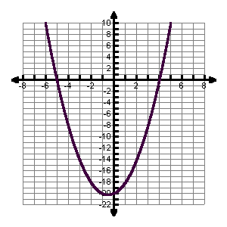 | b.  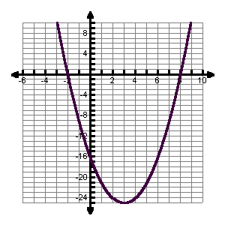
c.  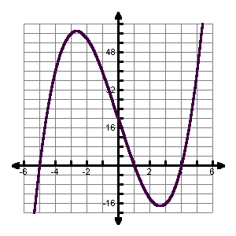 | d.  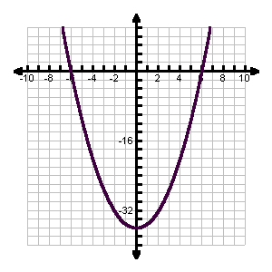
    - x² – 36 = 0 matches with graph _________; solutions: _______________

    - x² – 6x – 16 = 0 matches with graph _________; solutions: ______________

III. x² + x – 20 = 0 matches with graph _________; solutions: ______________

IV. x³ – 21x + 20 = 0 matches with graph _________; solutions: ___________

