Preparing for Graphing Systems of Equations
Section 4.1

Directions: Show all work (in pencil) in the spaces provided and write answers in the blanks.

- Solve the equation 2x – 5y = 10 for y. ________________

- Solve the equation for y to find the slope and the y-intercept of the linear equation
x + 2y = 6. Write the y-intercept as an ordered pair. Then use the slope and the y-intercept to sketch the graph of x + 2y = 6 in the coordinate plane below.

slope = _________

y-int. = _________

3. Analytically (paper & pencil) find the x-intercept and the y-intercept of the linear equation 2x - 3y = 9. Hint: To find the x-intercept let y = 0 and to find the y-intercept, let x = 0. Show all work, and write both intercepts as ordered pairs. Then sketch the graph of 2x - 3y = 9 in the coordinate plane below.
x-int. = _________

y-int. = _________

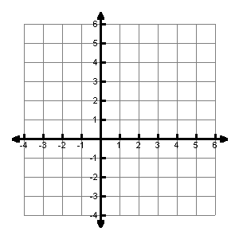
Problem 2 graph Problem 3 graph
4. Let Y1 = 0.25x + 50, where x represents the number of toothbrushes produced where Y1 represents the total cost of producing x toothbrushes. Fill in the table below. Then graph the equation in any viewing rectangle that “makes sense” in the context of this problem.

X | y
0
65
 | 80
210
 | 116.25

Interpret the meaning of the last entry in the table.

- The cost of ordering CDs from a mail-order house is $9.95 per CD plus $4.95 for shipping and handling per order. The equation represents the total cost, C, of ordering n CDs.

  - How much will it cost to order 2 CDs? __________

  - How much will it cost to order 5 CD? __________

  - If you have $64.65 to spend, how many CDs can you order? Find this answer algebraically, and show supporting work.
__________

  - If (n, C) represents any ordered pair that satisfies , interpret the meaning of (3, 34.8) in the context of this problem.

