TI-83/84 Binomial Experiments

You can use the TI-83/84 calculator to find the probability of x (number of successful trials) for a discrete binomial distribution.

Press 2ND and DISTR (above the VARS button). Arrow down and select A: binompdf( which stands for binomial probability density function.
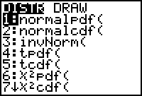

Enter n (number of trials), p (probability of success), and x (number of successful trials) separated by commas and then press ENTER and the TI-83/84 will calculate the probability.
Example: n=20, p=.50 find P(x=8)
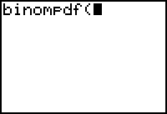

TI-83/84 also has a cumulative density function for the binomial distribution. This function adds the probabilities for 0 up to and including x. Select B: binomcdf( and enter n, p, and x.

Example: n=5, p=.6 find P(x≤ 3) Using binomcdf with x=3 will give us P(x=0,1,2,3)

Example: Only three out of four patients who have an artery bypass heart operation are known to survive five years without needing another bypass operation. Of seven patients who had such an operation, what is the probability that at least four will survive five years without needing another operation?

For this problem p = .75 and n = 7 find P(x≥4). Since binomcdf accumulates probabilities only from 0 up to and including x, then we’ll rewrite this to match the TI-83/84 capabilities: P(x≥4) = 1 - P(x≤3)

Example: Only three out of four patients who have an artery bypass heart operation are known to survive five years without needing another bypass operation. Of seven patients who had such an operation, what is the probability that at most four will survive five years without needing another operation?

For this problem p = .75 and n = 7 find P(x≤4). Since binomcdf accumulates probabilities from 0 up to and including x, then there is no need to rewrite this probability.

