TI-83/84 Boxplots

The TI-83 calculator will draw boxplots based upon the five-number summary values found under
1-Var Stats:
Minimum value
Quartile 1, or Q₁
Median
Quartile 3, or Q₃
Maximum value

Example
At Columbus State Community College, 15 students were selected at random from a group registering on the last day of registration. The times (in hours) necessary for these students to complete registration follow:

1.7 2.1 0.8 3.5 1.5 2.6 2.1 2.8
3.1 2.1 1.3 0.5 2.1 1.5 4.9

First enter the data in L₁.

Check the graphing window. Press the WINDOW key.
Enter Ymin = –5 and Ymax = 5 to position the axis in the window.
Xmin and Xmax will be determined by the data entered when you press Zoom 9.

The next step is to select the boxplot. Press 2nd STAT PLOT (above Y=). Highlight 1:Plot1 and press ENTER. Then on the next screen select On (put cursor on On and press ENTER) and the Type: boxplot with outliers (arrow right to the first graph in the second row). For this example the data is in L₁, so set Xlist to L₁ by pressing 2nd and the 1 key. Each data value is listed once for each time, so 1 is entered for Freq.

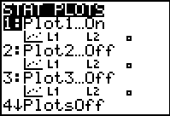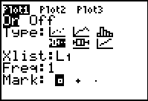

We are ready to graph the boxplot. Press Zoom 9.
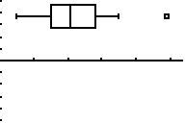

Press TRACE and notice that a blinking cursor appears. Use the right and left arrow keys to display the five-number summary. To leave the boxplot, press 2nd QUIT.

