TI83/84 Correlation: LinRegTTest

You can use the TI-83/84 calculator to determine the correlation between two variables, conduct hypothesis tests for a population correlation coefficient, calculate and graph the linear regression equation, and use the equation to predict y-values.

Turn Diagnostics On:
Before starting a regression problem, press 2nd CATALOG (above 0) and scroll down to the entry DiagnosticOn. Press ENTER twice. After doing this, the correlation coefficient r will appear with the linear regression equation. You only have to do this one time, unless you turn the diagnostics off.

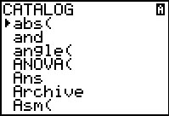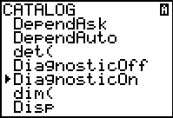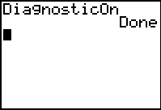

Find the regression equation, r, and r² and conduct a hypothesis test to determine if there is linear correlation:
Example: Let’s look at degrees north latitude vs. April air temperature. Use the data below to find the regression equation, r, r2, and to test for a linear relationship at the 10% level of significance:

Procedure:
- Enter the x-values (north latitude) in L₁ and y-values (April temperature) in L₂:

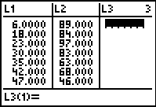
- Press STAT and arrow over to the TESTS menu
- Select E:LinRegTTest by highlighting the E and pressing ENTER or by typing E
- In the form that comes up enter the list name (L1) that contains your independent variable in Xlist: and the list name (L2) that contains your dependent variable in Ylist:
- Make sure that Freq: is set to 1
- Select the appropriate alternative hypothesis based on your problem statement by highlighting ≠0, <0, or >0 and pressing ENTER
- Leave RegEQ: blank
- Highlight Calculate and press ENTER to display the results:

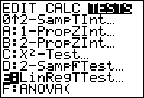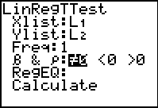
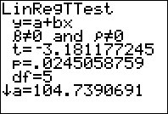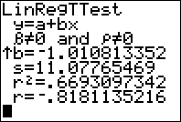

You can now complete your hypothesis test either by comparing the test statistic (t) to critical values or by comparing the p-value to the alpha level given in the problem. In this case, since the p-value is less than the alpha level given in the problem (.10) we reject H_{o} and can say that at the 10% level of signifigance there is enough evidence to say that there is a realationship between north latitude and April air temperature. We also know that this relationship is a negative one based on the sign of both b and r. This tells us that as we move further north the April temperature decreases.

Construct a scatter plot of the points:
- Press STAT PLOT (2nd Y=)
- Highlight 1:Plot1 and press ENTER.
- Select On (put cursor on On and press ENTER) and the scatter plot (first graph on the first row)
- Set Xlist to L₁ and set Ylist to L₂.
- Set your mark for each point by selecting a box, cross, or dot:

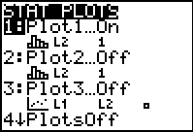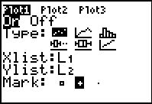

- Next press ZOOM and select 9:(ZoomStat) to set the graphing window and see the scatter plot
- You can also use the WINDOW button to set your window, but ZOOM 9 is easier:

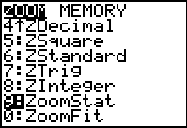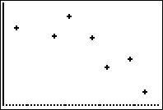

Overlay the regression equation on the scatter plot:
- To paste the regression equation in the graph, press Y= in the upper left hand corner
- Clear out any previous equations and press VARS
- Go to 5:Statistics and press Enter
- Use the arrow keys to highlight EQ, and then select 1:RegEQ (regression equation) and press Enter:

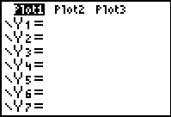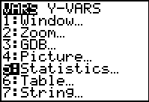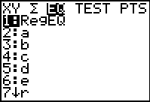

- The regression equation is pasted in Y=
- Press GRAPH and see the scatter plot with the regression equation:

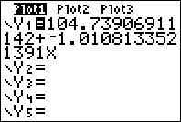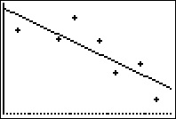

Predict y-values:
- Press CALC (2nd TRACE key)
- Highlight 1:value and press ENTER
- This will allow you to enter a value for x and find its predicted y-value
- To predict the April temperature for Columbus, Ohio (x =40), type 40 and press ENTER.
- A cursor will appear and you will see that Y=64.858 or 64.858 degrees.

