TI-83/84 Descriptive Statistics

The TI-83/84 calculator will directly give you many of the common descriptive statistics for a data set. The statistics given directly are:

Sample mean:
Sample standard deviation:
Population standard deviation:
Sample size: n
Minimum data value: min
Quartile 1: Q₁
Median: med
Quartile 3: Q₃
Maximum data value: max

Example
The table below gives the number of moons for each planet in the solar system.

Planet | Number of Moons
Mercury | 0
Venus | 0
Earth | 1
Mars | 2
Jupiter | 16
Saturn | 23
Uranus | 19
Neptune | 9
Pluto | 2

First enter the data into list L₁.

Press STAT again to highlight CALC and select 1:1-Var Stats. Press ENTER and the command 1-Var Stats will appear on the screen. Then tell the calculator to use the data in list L₁ by pressing the 2nd key and 1 key for list L₁.

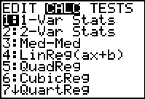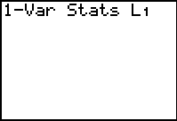

Press ENTER and the next two screens contain the descriptive statistics for the moon data. Note the arrow $↓$
on the last line. This tells you to use the down arrow key to display more results. Scroll down to see the rest of the results for the moon data.

To find the range, take the maximum value (maxX) and subtract the minimum value (minx). You can find the mode by sorting the data in ascending order and scanning the sorted list to see which value occurs most often. To sort the data, press STAT, highlight EDIT and select 2:SortA( which stands for sort in ascending order. Press ENTER and the SortA command appears on the screen. Type in L₁ and press ENTER. DONE appears on the screen. Press STAT and EDIT to return to list L₁ and notice that the data is now sorted in ascending order. A scan of the moon data shows that 0 and 2 are the modes.

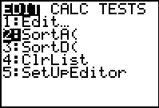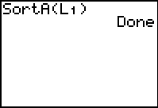

To leave the data screen, press 2nd QUIT.

