TI-83/84 Discrete Probability Distributions

You can use the TI-83/84 calculator to graph a discrete probability distribution as well as find the mean (expected value) and standard deviation of a discrete random variable.

Example: The manager of the Elmwood Café has a staff of six wait-persons on weekend evening shifts. For a period of 50 days she has recorded the number of these employees who called in sick. The results are given in the table below. In this problem x = number who call in sick. The frequency is the number of days x people call in sick.
Graph the discrete probability distribution and calculate the mean and standard deviation.

x | 0 | 1 | 2 | 3 | 4
Frequency | 30 | 10 | 5 | 3 | 2

First divide the frequencies by the sample size (n= sum of frequency column) to construct the probability distribution.

x | 0 | 1 | 2 | 3 | 4
P(x) | 30/50=.6 | 10/50=.2 | 5/50=.1 | 3/50=.06 | 2/50=.04

Press STAT and then select EDIT (#1). Enter the random variable x in L₁ and P(x) in L₂ (you can enter the fractions in L2 and when you press enter the decimal will appear).
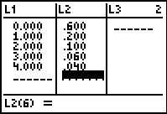

Now we will set the graphing window so that we can see the graph of the discrete probability distribution.
Press the WINDOW key.
Select Xmin and enter the lowest value of the random variable. For this example, Xmin = 0.
Select Xmax and enter the total number of values of the random variable. For this example, Xmax = 5.
Select Xscl and enter 1 (each bar will be 1 unit wide).
Set Ymin = 0
Select Ymax and enter a value above the highest probability (0.60 for this example). For this example Ymax = 0.7.

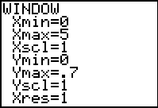

The next step is to select the histogram for the plot. Press 2nd STAT PLOT (above Y=). Highlight 1:Plot1 and press ENTER. Then on the next screen select On (put cursor on On and hit ENTER) and the histogram shape (third graph on the first row).

Set the Xlist to L₁ by pressing 2nd and the 1 key. For the Freq (frequency) select L₂ by pressing 2nd and the 2 key.

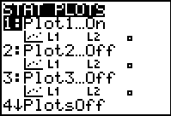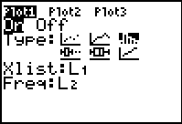

We are ready to graph the discrete probability distribution. Press GRAPH.

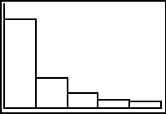

Press TRACE and notice that a blinking cursor appears over the first bar. The probabilities P(x) are given by n. Use the right and left arrow keys to move from bar to bar.

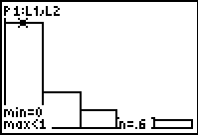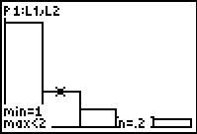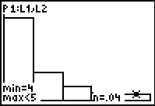

To leave the discrete probability distribution, press 2nd QUIT.

To find the mean (expected value) and standard deviation, press the STAT key, highlight CALC using the arrow keys and then select the 1-VAR STATS option (#1). Then enter L₁, L₂. Remember L₁ is x and L₂ is P(x).
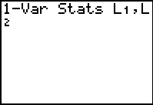

Press ENTER to view the descriptive statistics.

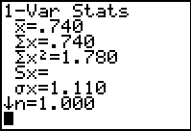

The mean (expected value) is 0.740 and the standard deviation is 1.110

