TI-83/84 Entering Data

To use the statistical functions built into the TI-83/84, we first have to enter data into lists. The TI-83/84 has six columns (called lists L₁, L₂, L₃, L₄, L₅, and L₆) in which data can be entered.

Press the STAT key and then select 1:Edit. You will now see the data screen with the six lists, L₁ through L₆ (use your right arrow to see L₄ through L₆).

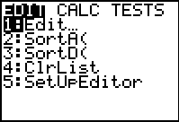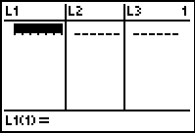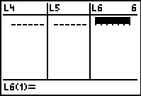

If there is already data in one of the lists, we need to clear the list. Do this by placing your cursor at the top of the list you wish to clear and then press the CLEAR button. DO NOT press the DEL button - this will delete the list from your calculator. Another way to clear a list is to press the STAT key and then select 4:ClrList using the arrow keys, and then press ENTER. Then type in the list you want cleared (2ND key and 1 key for list L₁) and press ENTER.

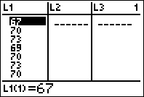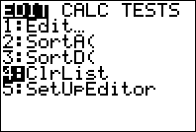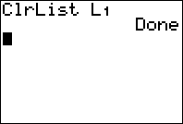

We are now ready to enter data into the lists. Let’s enter the numbers

2 5 7 9 11 in list L₁
3 6 9 1 12 in list L₂

Press ENTER after each number, and use the arrow keys to move between L₁ and L₂. To correct a data entry, highlight the entry that is wrong and enter the correct data value. To delete a data entry, highlight the data value you wish to delete and press the DEL key. To insert a new entry into a list, highlight the position directly below the place you wish to insert the new value and then press 2nd INS and then enter the data value.

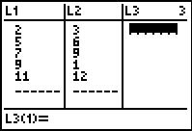

You can also create new lists by doing arithmetic on existing lists. For example, let’s create L₃ by using the formula L₃ = 2L₁ + L₂. Place your cursor at the top of L3. Then type in 2L₁ + L₂ and press ENTER. The result is shown below.

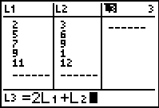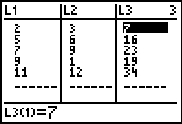

To leave the data screen, press 2nd QUIT.

