TI-83/84Frequency Histograms

The TI-83/84 calculator will draw histograms for data entered in the data lists.

Example
Throughout the day from 8 a.m. to 11 p.m., a viewer counted the number of ads occurring every hour on one commercial T.V. station. The 15 data values are:

10 12 8 7 15 6 5 8
8 10 11 13 15 8 9

Construct a histogram with 4 classes.

First enter the data in L₁.

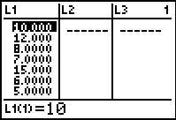

Next we have to set the graphing window. We will need to know the lower class boundary for the first class and the class width (see your notes and book on how to find these values).

The minimum is 5, so the lower class boundary of the first class is 4.5.

The class width = = $\frac{\text{15}−5}{4}$ = 2.5 = 3 (always go up to the next whole number)

Now we will set the graphing window. Press the WINDOW key.
Select Xmin and enter the lower class boundary of the first class. For this example, Xmin = 4.5.
Select Xmax = 17 ensures that the histogram fits on the screen, since our highest data value is 15.
Select Xscl and enter the class width. For this example, Xscl = 3.
Setting Ymin = –5 and Ymax = 15 makes the histogram fit comfortably on the screen.

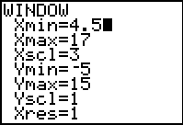

The next step is to select the histogram for the plot. Press 2nd STAT PLOT (above Y=). Highlight 1:Plot1 and press ENTER. Then on the next screen select On (put cursor on On and hit ENTER) and the histogram shape (third graph on the first row). For this example the data is in L₁, so set Xlist to L₁ by pressing 2nd and the 1 key. Each data value is listed once for each time, so 1 is entered for Freq.

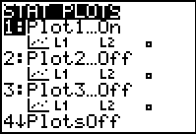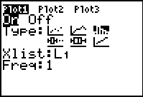

We are ready to graph the histogram. Press GRAPH.

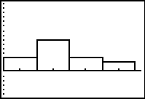

Press TRACE and notice that a blinking cursor appears over the first bar. The class boundaries of the bar are given as min and max and the frequency is given by n. Use the right and left arrow keys to move from bar to bar. The calculator has done the work of sorting the data and tallying the data for each class.

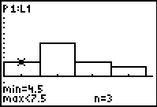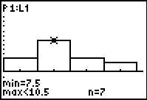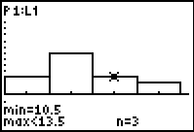

To leave the histogram, press 2nd QUIT.

