TI-83/84 Poisson Probability Distributions

You can use the TI-83/84 calculator to find the probability of some event occurring x times over an interval for the Poisson distribution.

Hit 2ND and DISTR (above the VARS button) buttons. Arrow down and select B: poissonpdf( which stands for Poisson probability density function.

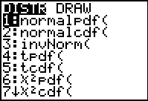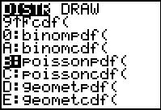

Enter $μ$ (mean over a given interval) and x (number of times event occurs over the interval) separated by commas and then hit ENTER and the TI-83//84 will give you the correct probability.

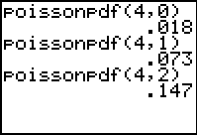

The TI-83/84 also has a cumulative density function for the Poisson distribution, which computes a cumulative probability for specified values of x (adds the probabilities for 0 up to and including x.)

Select C: poissoncdf( from above and enter $μ$ and x. Notice that the display below added up the probabilities of x = 0, 1, 2 from the screen above.

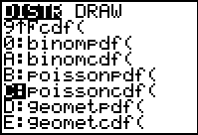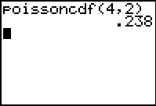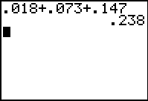

Example: According to e-mail logs, an employee receives and average of 110 e-mails per week. The e-mails follow a Poisson distribution.

- What is the probability that the employee receives 200 e-mails over a two-week period?
- What is the probability that the employee receives at most 200 e-mails over a two-week period?
- What is the probability that the employee receives at least 200 e-mails over a two-week period?

For this problem the mean$μ$ = 2(110) = 220

- We want P(x = 200) = 0.011

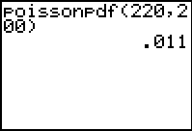

- We want P(x 200) = 0.093
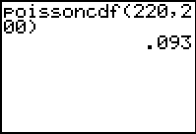

- We want P(x200) = 1 – P(X 199) = 0.918

