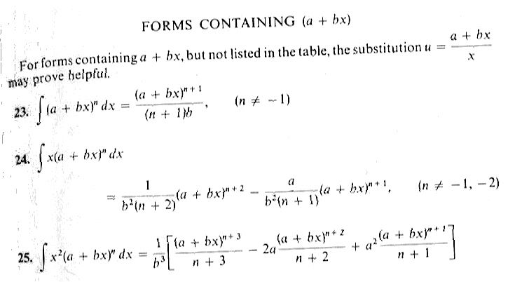
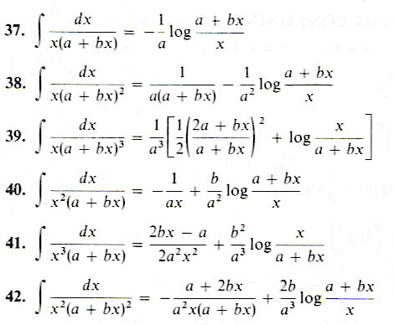
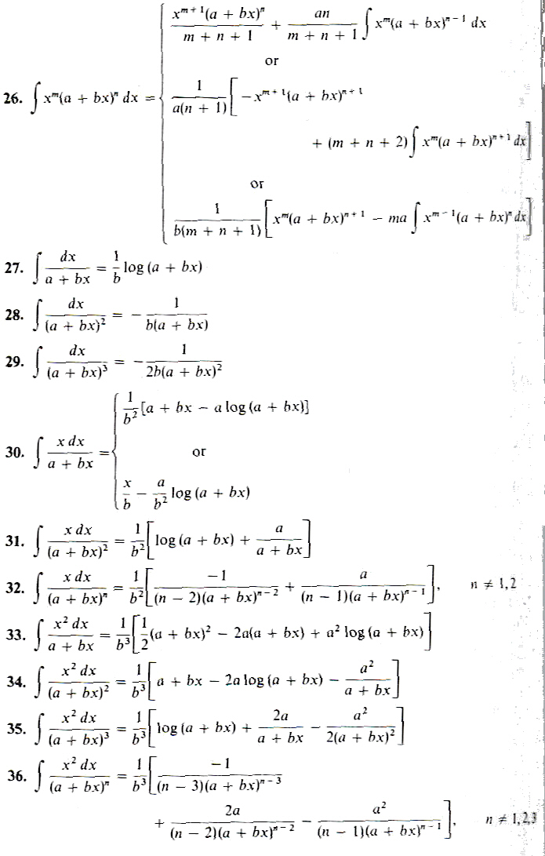

Name __________________________________________________________
Math 2170, Pop Quiz #6, Spring 2006

1. Using the attached tables, integrate
$$\int{\frac{\text{cos}x\text{sin}\text{xdx}}{1+6\text{cos}x+9{\text{cos}}^{2}x}}$$

2. Determine whether the improper integral converges or diverges. If it converges, give the value it converges to.
$$\int_{0}^{∞}{\frac{e^{x}}{1+e^{x}}}\text{dx}$$

