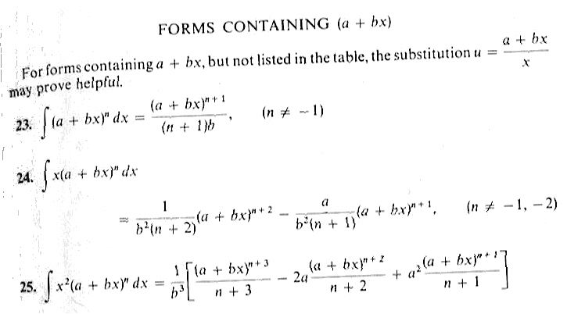
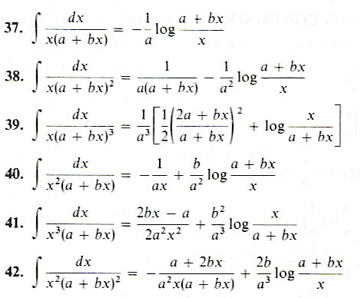
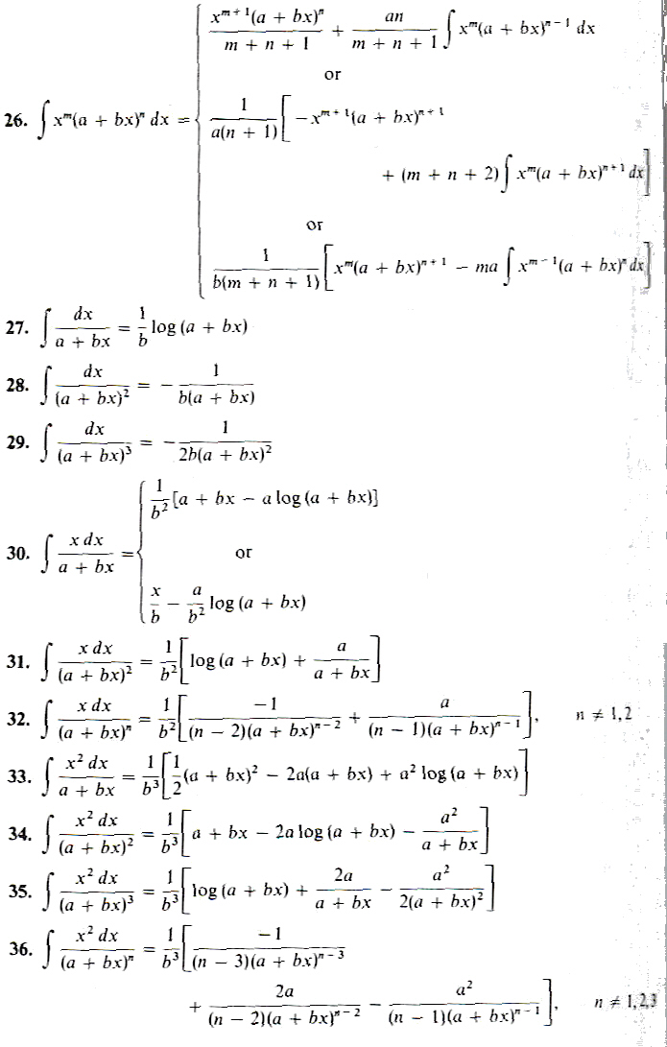

Name __________________________________________________________
Math 2170, Pop Quiz #6, Spring 2006

1. Using the attached tables, integrate
$$\int{\frac{\text{cos}x\text{sin}\text{xdx}}{1+6\text{cos}x+9{\text{cos}}^{2}x}}$$
since we have both sines and cosines in the problem, we should make a substitution before proceeding
$$\begin{aligned}u=\text{cos}x \\ \text{du}=\text{sin}\text{xdx} \\ \int{\frac{\text{udu}}{1+6u+9u^{2}}}=\int{\frac{\text{udu}}{{\left(1+3u\right)}^{2}}}\end{aligned}$$
this matches formula #31, with a=1 and b=3
$$=\frac{1}{9}\left[\text{log}\left(1+3u\right)+\frac{1}{1+3u}\right]=\frac{1}{9}\left[\text{ln}\left(1+3\text{cos}x\right)+\frac{1}{1+3\text{cos}x}\right]+C$$
the book I copied the tables from uses “log” in place of “ln

2. Determine whether the improper integral converges or diverges. If it converges, give the value it converges to.
$$\int_{0}^{∞}{\frac{e^{x}}{1+e^{x}}}\text{dx}$$

$$\begin{aligned}u=1+e^{x} \\ \text{du}=e^{x}\text{dx} \\ \int{\frac{e^{x}}{1+e^{x}}\text{dx}}=\int{\frac{1}{u}\text{du}=}\text{ln}(1+e^{x}) \\ \underset{b→∞}{\text{lim}}\text{ln}(1+e^{x})|_{0}^{b}=\underset{b→∞}{\text{lim}}\text{ln}(1+e^{b})+\text{ln}(1+e^{0})=∞\end{aligned}$$
This integral diverges because as b goes to infinity, ln(1+e^{b}) goes to infinity

