Name ______________________________________________
Exam II, Math 116, Spring 2007

1. Determine if the following graphs have an Euler circuit, an Euler path or neither. Explain your reasons for choosing each. Label all odd vertices.
a) 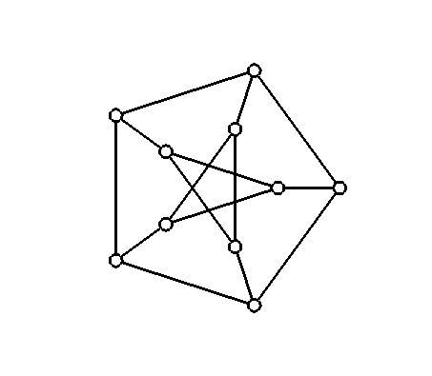 b) 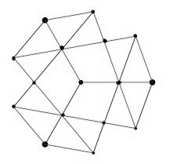
neither, all vertices odd neither, 10 odd vertices, 6 even
c)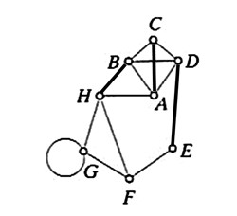Euler path, 2 odd vertices

2. For the graph below, find an eulerization of the graph. State the minimum number of edges needed to do this (under ideal circumstances). Then find a unicursal tracing for your Eulerized graph. Number the edges as you cross them.
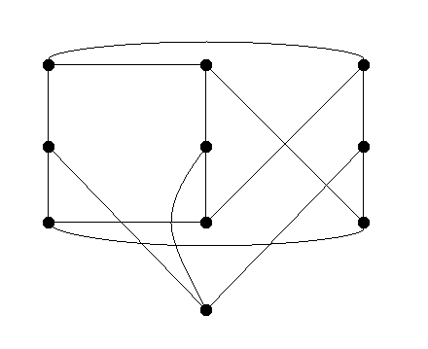
10 odd vertices means minimally add 5 edges. Answers will vary
3. For the graph below:
a) determine if the graph satisfies Dirac’s theorem. Explain why you think so.

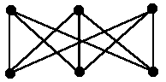

Yes, since there are six vertices, each vertex is at least degree 3.

b) How many edges would you need to add to make this graph complete? Draw in the edges you need to create the complete graph K₆.

Add two edges per vertex, or 6.
K₆ should have 15 edges, this graph has 9, thus 15-9=6.

c) How many unique Hamilton circuits exist on K₆?

120

4. Find a Hamilton circuit on the graph below. Number the edges as you draw the circuit.
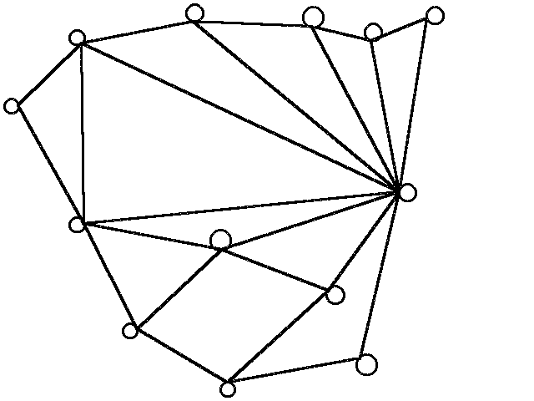
Answers will vary.
5. Use the nearest-neighbor algorithm to solve the traveling salesman problem represented by the table below. List the locations as you visit them. If the numbers represent miles, give the final total miles of your journey. Begin and end in Euclid.

Cities | Akron | Berea | Chardon | Euclid | Geneva | Mentor | Parma
Akron | * | 89 | 36 | 48 | 52 | 45 | 67
Berea | 89 | * | 61 | 32 | 76 | 56 | 27
Chardon | 36 | 61 | * | 26 | 29 | 12 | 55
Euclid | 48 | 32 | 26 | * | 37 | 20 | 39
Geneva | 52 | 76 | 29 | 37 | * | 23 | 66
Mentor | 45 | 56 | 12 | 20 | 23 | * | 39
Parma | 67 | 27 | 55 | 39 | 66 | 39 | *

Euclid – Mentor – Chardon – Geneva – Akron – Parma – Berea – Euclid.
239

6. On the graph below, use the cheapest link algorithm to find a Hamilton path starting at C and ending at B. List the Hamilton path you find and its final weight.
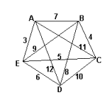
C – E – A – D – B 28

7. For the graph below:
a) Determine the number of edges needed to create a tree, and the redundancy of the graph.
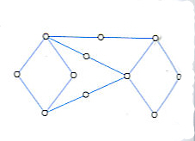
10 edges, redundancy = 4

b) Find three spanning trees of the graph. Label the edges included in the first spanning tree 1, the second spanning tree 2, then third spanning tree 3.

Answers will vary

8. Suppose the graph below represents a network. Use Kruskal’s algorithm to find a minimal spanning tree. Give the value of that tree.

AE, EC, BC, DE = 18

9. Consider the triangle below. Find the location of the Steiner point for this network.

Vocabulary and concepts.
10. Explain the difference between an Euler path and an Euler circuit. What criterion is different, and which is the same?

Both are connected. But an Euler path is permitted to have two odd vertices while an Euler circuit may have none.

11. Fleury’s algorithm allows us to do what? Describe it.

To find an Euler path/circuit on a graph. Start, choose an edge, subject to not choosing a bridge to untraveled graph (cutting off access to part of the graph). When there is only one choice, take it.
12. A Hamilton path differs from an Euler path in what way?

A Hamilton path touches all the vertices once (only), but an Euler path touches each edge once (only).

13. Explain what an optimal algorithm is. Explain why the brute-force method, even though it’s optimal, is almost never used for large graphs.

An optimal algorithm is guaranteed to give the minimal circuit. The brute force method is almost never used because the amount of work increases faster than exponentially as the number of edges increases.

14. Explain the difference between the nearest neighbor method and the repetitive nearest neighbor method.

Nearest neighbor starts at the starting point and selects the shortest route to the next step at each location. The repetitive nearest neighbor builds on this by repeating this process for each vertex. The shortest route is chosen and then shifted to start at the desired starting point.

15. List three main properties any tree must have.

Only one path to each vertex from any other, every edge is a bridge, N vertices implies N-1 edges.

16. We should calculate a Steiner point whenever what condition is true?

3 vertices form a triangle where all the angles are less than 120 degrees

