Name ____________________________________________________
Quiz 5, Math 116, Spring 2007

Use the following graph for problems 1 and 2.
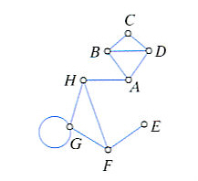
1. Give the set of vertices and the set of edges for the graph above.

V={A,B,C,D,E,F,G,H}
E={EF,FG,FH,GG,GH,HA,AB,AD,BC,BD,CD}

2. Find a path from vertex C to vertex E. Indicate your path on the graph by numbering the edges as you travel them.

Answers may vary

Use the graph below for problem 3.
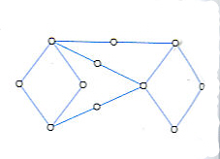

3. For the graph above, determine whether there exists and Euler Circuit, and Euler Path, or none. Explain your choice.

Euler Path, there are two odd vertices

