Name_______________________________________________________
Quiz 6, Math 116, Spring 2007

1. Find an eulerization for the graph below.
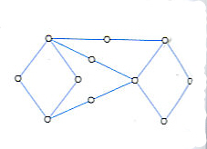answers may vary
2. Find a Hamilton circuit that starts at point A.
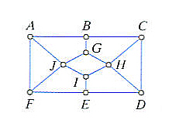answers may vary
3. For a complete graph K₆, find the following:
a) The number of edges in the graph.
15

b) the number of distinct Hamilton circuits of the graph.

120

4. The following table gives distances between seven cities. A band is touring each city before returning to their home in Boston. Use the nearest-neighbor algorithm to plan a route that visits each city and returns to Boston. List the cities in the order they should be visited. Give the total miles of the trip.
 | Boston | Dallas | Houston | Louisville | Nashville | Pittsburgh | St. Louis
Boston | * | 1748 | 1804 | 941 | 1088 | 561 | 1141
Dallas | 1748 | * | 243 | 819 | 660 | 1204 | 630
Houston | 1804 | 243 | * | 928 | 769 | 1313 | 779
Louisville | 941 | 819 | 928 | * | 168 | 388 | 263
Nashville | 1088 | 660 | 769 | 168 | * | 553 | 299
Pittsburgh | 561 | 1204 | 1313 | 388 | 553 | * | 588
St. Louis | 1141 | 630 | 779 | 263 | 299 | 588 | *
Boston, Pittsburgh, Louisville, Nashville, St. Louis, Dallas, Houston, Boston
Total: 4093

