Name ______________________________________________________
Quiz #7, Math 116, Spring 2007

1. Use the cheapest link algorithm to find a solution to the TSP below. State the vertices visited in order starting from vertex E, and the final value of the circuit.
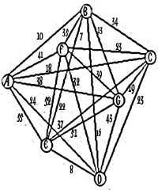

2. For the graph in #1, explain how to perform the repetitive nearest neighbor algorithm. (You do not need to actually perform the algorithm.)

3. List three properties of a tree.

a)

b)

c)

4. Below are four graphs (of molecules). Which ones are trees? If it is not a tree, find a spanning tree for the graph (indicate on the graph which edges should be contained in the tree), and find its redundancy.
a) 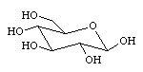 b) 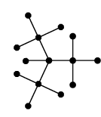

c) 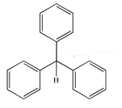 d) 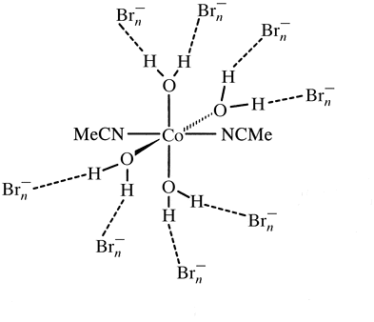

5. Define a minimal spanning tree.

