Name ______________________________________________________
Quiz #7, Math 116, Spring 2007

1. Use the cheapest link algorithm to find a solution to the TSP below. State the vertices visited in order starting from vertex E, and the final value of the circuit.
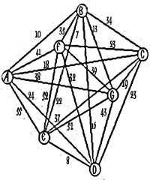

E – B – A – C – G – F – E = 133

2. For the graph in #1, explain how to perform the repetitive nearest neighbor algorithm. (You do not need to actually perform the algorithm.)

Perform the nearest neighbor algorithm from each vertex, then rewrite from desired starting point.

3. List three properties of a tree.

a) only one path joining each vertex to any other vertex (no circuits)

b) each edge is a bridge

c) N-1 edges for N vertices

4. Below are four graphs (of molecules). Which ones are trees? If it is not a tree, find a spanning tree for the graph (indicate on the graph which edges should be contained in the tree), and find its redundancy.
a) 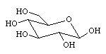 b) 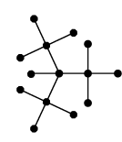

no, answers vary, R=1 yes

c) 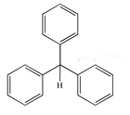 d) 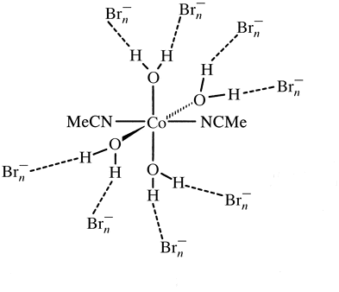

no, answers vary, R=3 yes

5. Define a minimal spanning tree.

a spanning tree of least weight.

