TI-83/84 Expected values

You can use the TI-83/84 calculator to find expected value (mean) of a probability model.

Example #1: Tickets for a group’s fund-raiser are sold for $1. One ticket will be randomly chosen and the winner will receive a $500 gift card to Best Buy. They expect to sell 1000 tickets. You purchase 1 ticket for the fund-raiser. Find the expected value of your ticket.

Your ticket has a 1/1000 probability of winning and a 999/1000 chance of losing. There are two outcomes for your ticket: You win $500 (net gain is $499) or you do not win (net “gain” is –$1)

Gain: | $499 | –$1
Probability: | 1/1000 | 999/1000

Press STAT and then select EDIT (#1). Enter the gain in L₁ and the probabilities in L₂.
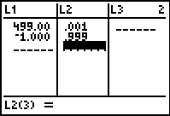

To find the expected value, press the STAT key, highlight CALC using the arrow keys and then select the 1-VAR STATS option (#1). Then enter L₁, L₂. Remember L₁ is the gain and L₂ is the probabilities.
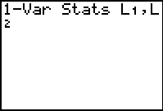

Press ENTER to view the descriptive statistics.

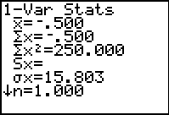

The expected value (mean) is –0.500 or –50¢, which means that you can expect to lose, on average, 50¢ for each ticket you buy.

Example #2: The manager of the Elmwood Café has a staff of six wait-persons on weekend evening shifts. For the past several years, she has recorded the number of employees who called in sick. The results are given in the table below. Find the expected number of wait-persons that will call in sick?

Number of Employees: | 0 | 1 | 2 | 3 | 4
Probability: | 0.60 | 0.20 | 0.10 | 0.06 | 0.04

Press STAT and then select EDIT (#1). Enter the number of employees in L₁ and the probabilities in L₂.
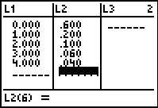

To find the expected value, press the STAT key, highlight CALC using the arrow keys and then select the 1-VAR STATS option (#1). Then enter L₁, L₂. Remember L₁ is number of employees and L₂ is the probabilities.

Press ENTER to view the descriptive statistics.

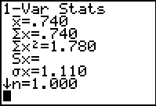

The expected value (mean) is 0.740, which means that she can expect, on average, 0.740 workers to call in sick.

