MAT 135, Discussion Questions for Module 2

- Explain in your own words why we need to understand how to read graphs.

- What is the difference between a time series graph and a cross-sectional graph?

- What are some potential problems with pictographs? For context:
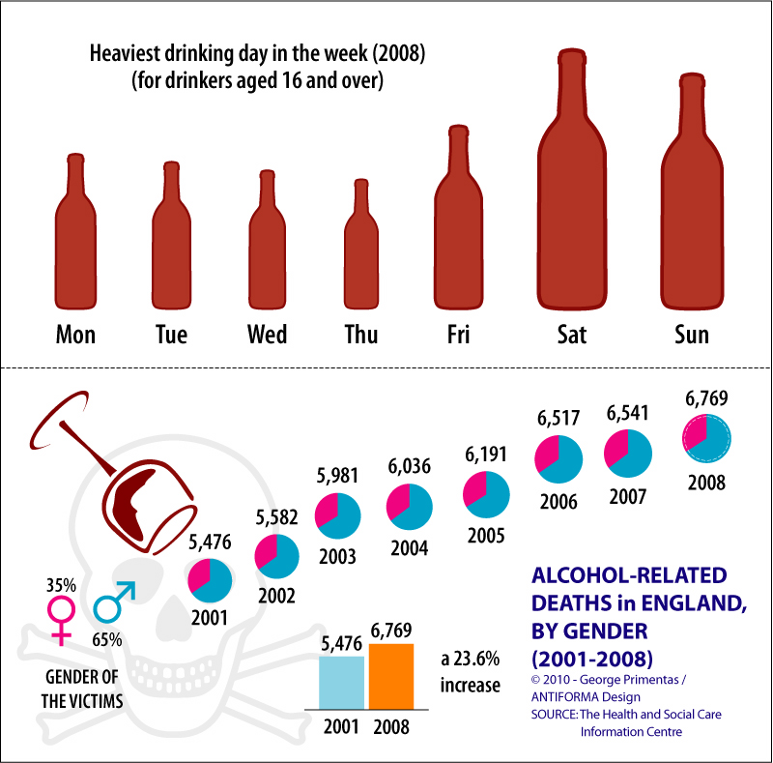
- Give one reason why the scale of a graph matters.

- Classify each of the distributions/graphs below as roughly 1) uniform, 2) symmetric, 3) skewed left, 4) skewed right, or maybe none of these.
- 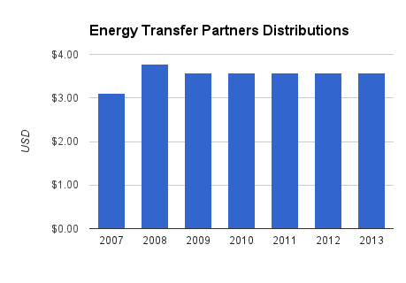f. 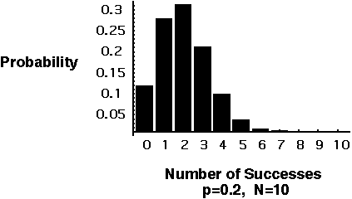
- 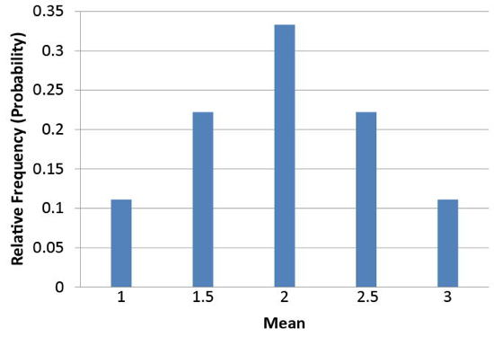g. 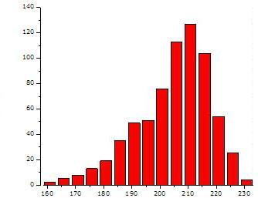
- 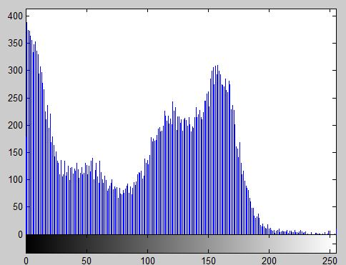h. 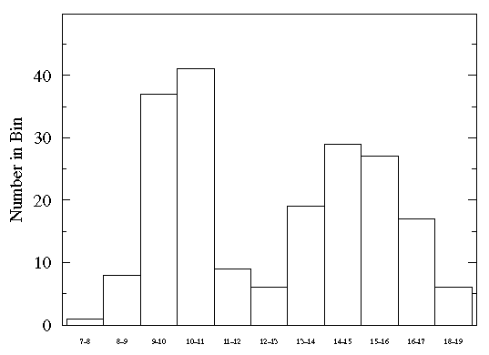
- 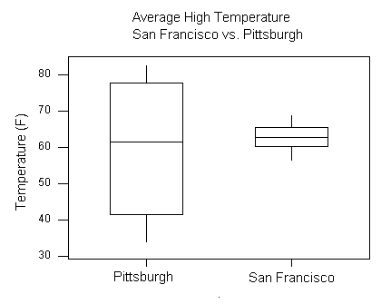i. 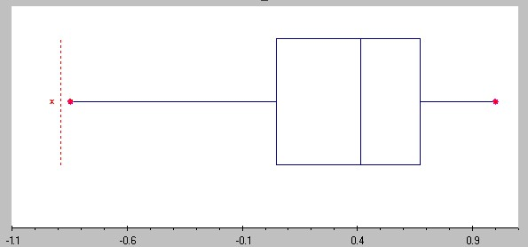
- 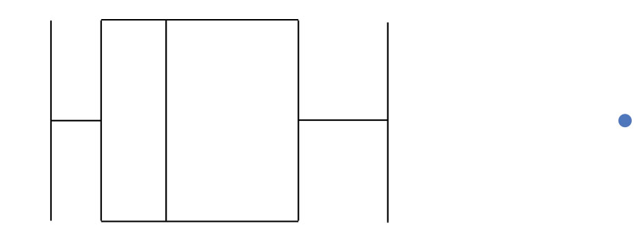

- When analyzing graphs, what 4-5 things should you be looking for in each graph? (If you prefer, you can give 1-2 things per graph type, for 4-5 different types.)

- Bring some bad graphs (or data visualizations) to share with the class. You can find them on Google, or try the site: http://viz.wtf/. Bring one to share, preferably in English. Be able to explain why your example is an example of a bad graph.

- The formula for the mean is
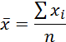
Describe what this formula means in your own words.

- How does the median differ from the mean? When are the two values going to be the same (or nearly so)?

- What is the mode? Can there be more than one?

- When should each measure of center be used as a “typical” value?

- How do the mean, median and mode relate to each other in a 1) symmetric distribution? 2) skewed left distribution? 3) skewed right distribution?

- Consider the data set for presidential ages at inauguration we saw earlier. I’ve dropped the decimals (for number of days), so that we can look at their ages in a more typical fashion.
President | AGE (in years) | President | AGE (in years)
George Washington | 57 | Benjamin Harrison | 55
John Adams | 61 | Grover Cleveland | 55
Thomas Jefferson | 57 | William McKinley | 54
James Madison | 58 | Theodore Roosevelt | 42
James Monroe | 58 | William Howard Taft | 51
John Quincy Adams | 57 | Woodrow Wilson | 56
Andrew Jackson | 61 | Warren G. Harding | 55
Martin Van Buren | 54 | Calvin Coolidge | 51
William Henry Harrison | 68 | Herbert Hoover | 54
John Tyler | 51 | Franklin D. Roosevelt | 51
James K. Polk | 49 | Harry S. Truman | 60
Zachary Taylor | 64 | Dwight D. Eisenhower | 62
Millard Fillmore | 50 | John F. Kennedy | 43
Franklin Pierce | 48 | Lyndon B. Johnson | 55
James Buchanan | 65 | Richard Nixon | 56
Abraham Lincoln | 52 | Gerald Ford | 61
Andrew Johnson | 56 | Jimmy Carter | 52
Ulysses S. Grant | 46 | Ronald Reagan | 69
Rutherford B. Hayes | 54 | George H. W. Bush | 64
James A. Garfield | 49 | Bill Clinton | 46
Chester A. Arthur | 51 | George W. Bush | 54
Grover Cleveland | 47 | Barack Obama | 47
Find the mean and the median (in your calculator if you can). How can you use the calculator to help you find the mode?

- How do we calculate the range of a data set?

- Describe the procedure for calculating a standard deviation by hand (i.e. 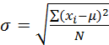 or 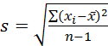, unpack this formula. What is it telling you to do, in order?).

- What is another formula we can use to find the standard deviation?

- How do you find these values in your calculator?

- One interpretation of the standard deviation is that it is the average distance from the mean. What does this measure in statistical terms?

- Sketch the Empirical Rule on the graph below.
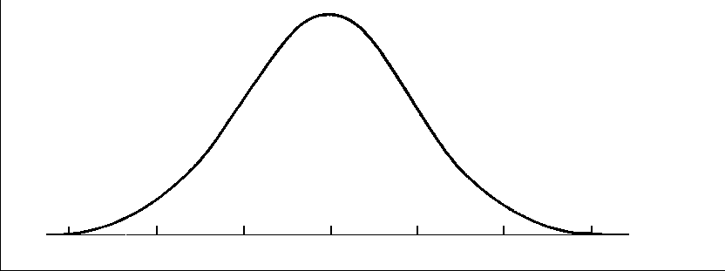

- Why is the median used to describe income and not the mean?

- Visit the graphic http://www.statslife.org.uk/images/pdf/timeline-of-statistics.pdf and choose a point in the history of statistics that seems really important to you. Be prepared to explain why.

- How does the formula for a weighted average differ from the general formula for the arithmetic mean?

- How do we calculate a weighted mean in the calculator? Or the mean for grouped data?

- What is the coefficient of variation?

- Why is the coefficient of variation needed to compare data sets with different means and different standard deviations?

- Using the Empirical Rule (a slightly more accurate version is shown on the graph below), find the percentages (area) under the distribution curve between the indicated z-scores.
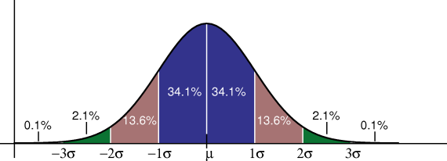
- 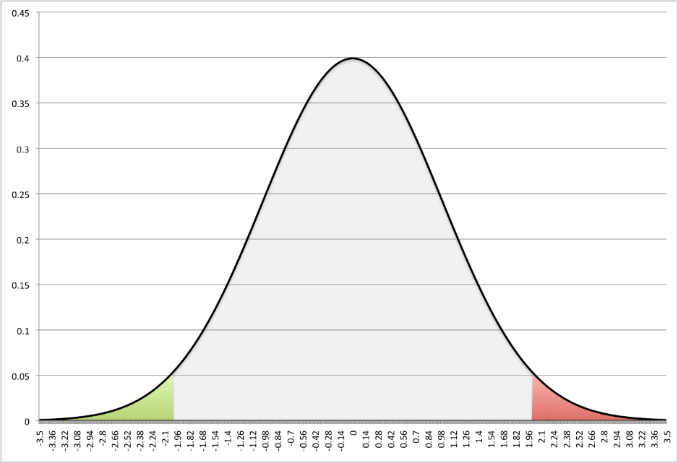
- 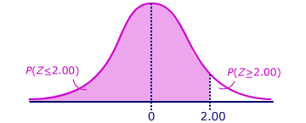c. 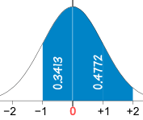

- Based on the graph below, what is the mean height of men? What is the mean height of women? Which group has a larger standard deviation?
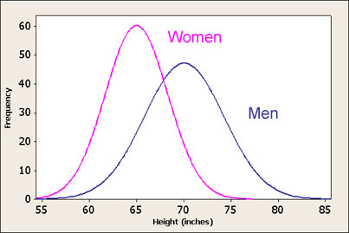

- Read the article at http://bigthink.com/ideafeed/how-we-learn and the rest of the interview linked in the article. Can any of these strategies help you in this class?

- When someone says they are above the 90th percentile, what does that mean?

- If you have an ordered list of 38 terms, and you want to determine which element in the list is the 85th percentile, how do you do it? Which element is it?

- What percentile is the 14th element in the list?

- What percentile is the median value? What is the percentile for the first quartile? Third quartile?

- Consider the data set
14 | 36 | 40 | 43 | 44 | 49 | 51 | 51 | 55 | 55
55 | 56 | 61 | 61 | 63 | 67 | 70 | 75 | 78 | 82
- What is the median?

- What is Q1? What is Q3?

- What is the interquartile range (IQR)?

- How can you tell from a boxplot If the distribution is skewed or symmetric?

- What temperature represents approximately the 38th percentile based on the box plot shown?
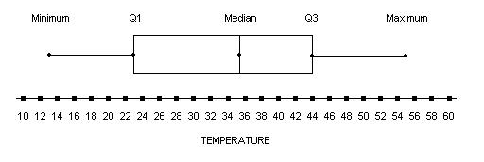

- Find the shaded area for the shaded region using the table of z-values from the textbook.
- Find the shaded area under the curve if the mean is 0 and the standard deviation is 1. The cut-off score here is .
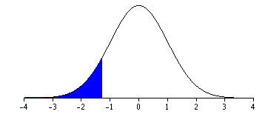
- Find the shaded area under the curve for the cut-off value .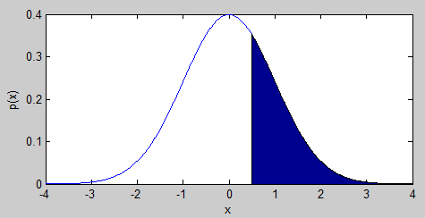
- // d. /

- What is the percentile of each of these cut-off scores in the graphs above?

- What is the standard score of someone whose IQ is 135 if the mean of the distribution is 100 and the standard deviation is 15?

- If a student takes the ACT, which has a mean of 21 and a standard deviation of 5.2, and obtains a score of 25, do they have a higher or lower score than another student who took the SAT, which has a mean of 1498 and a standard deviation of 199, obtained a score of 1780.

- Who is smarter? Someone with an IQ of 148 with a mean of 100 and a standard deviation of 15, or someone with an IQ of 167 with a mean of 110 and a standard deviation of 20?

- Your calculator has two boxplot graphing functions. How are they different?

- Is the price of an airline ticket related to the number of miles traveled? The mileage between Washington, DC and some selected cities is given below along with the average price of an airline ticket from Washington to that city:

Mileage | 4500 | 1000 | 2000 | 300 | 350 | 500 | 600 | 850
Price | 1450 | 690 | 1050 | 400 | 800 | 670 | 725 | 620
Mileage | 1700 | 330 | 1500 | 450 | 100 | 3100 | 1100
Price | 550 | 480 | 800 | 650 | 250 | 1200 | 650

- What is the explanatory variable? What is the response variable?

- Use the graph below to construct a scatterplot of the data. Be sure to include correct labels.

- What is the relationship between slope and correlation?

- Determine if the following graphs are displaying a linear relationship between the variables. Is the correlation positive, negative or zero?
- 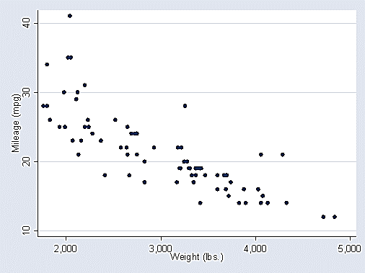 d. 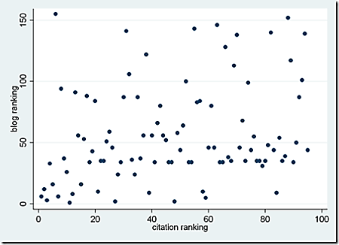
- 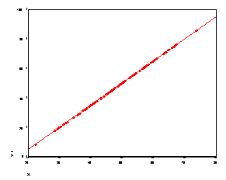 e. 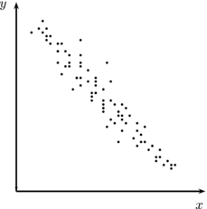
- 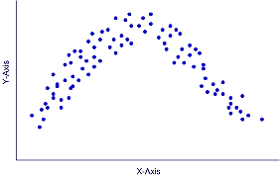 f. 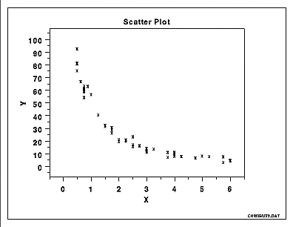

- What is the range of values the correlation can take?

- What is the coefficient of determination? What does it mean, and how is it related to the correlation coefficient?

- Why does correlation not imply causation? Give an example of confounding to illustrate your point.

- Which of the following graphs show a strong correlation? A moderate correlation? A weak correlation? No correlation?
- 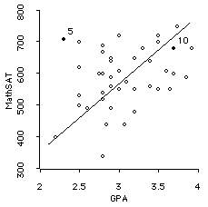b. 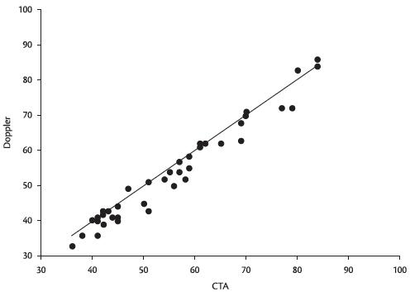
c-e. 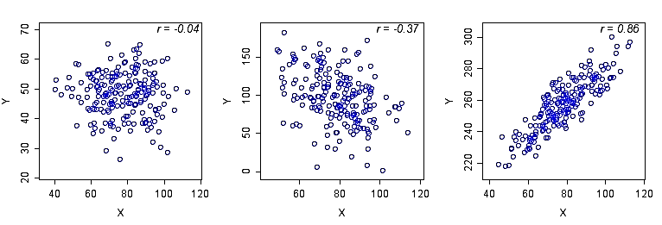

- Read the article here https://statswithcats.wordpress.com/2015/01/01/how-to-tell-if-correlation-implies-causation/. Be prepared to talk about it.

- 