Name ______________________________ Drill 4—Math 118—Summer 2007

1. Define a Hamilton circuit.

2. Find a Hamilton circuit on the graph below. Label the edges with arrows as you travel them and mark your starting and stopping points.

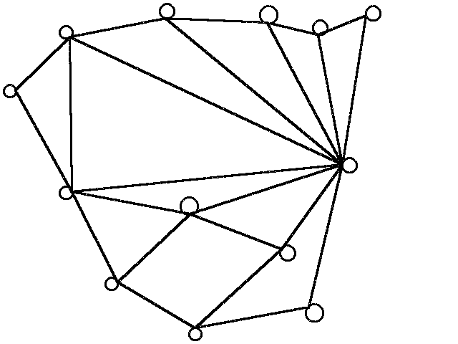

3. What is Dirac’s Theorem? Use it to determine if any of the graphs on pg. 199, Figure 6-3, must have at least one Hamilton circuit.

4. Describe in words what a complete graph is.

5. If a complete graph has 9 vertices, how many edges are on the graph? How many distinct Hamilton circuits does it have?

6. Describe a situation in which you might have to solve a traveling salesman problem.

7. How are Hamilton circuits related to traveling salesman problems (TSPs)?

