Name ________________________________ Drill 5—Math 118—Summer 2007

1. Describe what is meant by “optimal” when describing solutions to TSPs.

2. What are the advantages and disadvantages to the Brute-Force Algorithm?

3. What are the advantages and disadvantages to the Nearest Neighbor Algorithm?

4. What is the difference between an efficient algorithm and an optimal one?

5. Is the Brute-Force Algorithm optimal or efficient? Is the Nearest Neighbor Algorithm optimal or efficient?

6. Use the graph below and find the best route using the Nearest Neighbor Algorithm starting at vertex C.

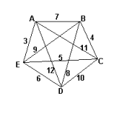

7. Explain why mathematicians are forced to resort to approximate algorithms when solving TSPs? What is an approximate algorithm?

