Name ________________________________ Drill 7—Math 118—Summer 2007

1. Define a spanning tree of a network.

2. If the network has 17 vertices and 36 edges, how many edges are needed to form a spanning tree? What is the redundancy of the network?

3. Explain the steps in Kruskal’s Algorithm.

4. Use Kruskal’s Algorithm to find the minimal spanning tree of the network below. What is the weight of MST?
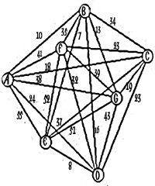

5. What is the difference between a native junction and an interior junction?

6. What is a Steiner point and what are its advantages? Under what conditions would you look to find one?

8. Describe the steps in Torricelli’s Construction for finding a Steiner point in your own words.

