Name ________________________________ Exam #2—Math 118—Summer 2007

1. Determine if any of the graphs below have a Hamilton circuit. If they do, find one and label the edges in the order you’d traverse them. If there is no Hamilton circuit, determine if there is a Hamilton path. If so, label it as with the Hamilton circuit. If neither, write NONE.

a. 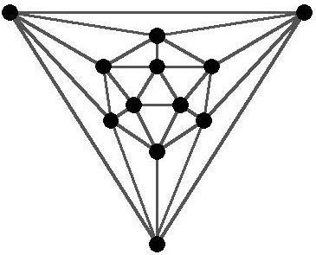 b. 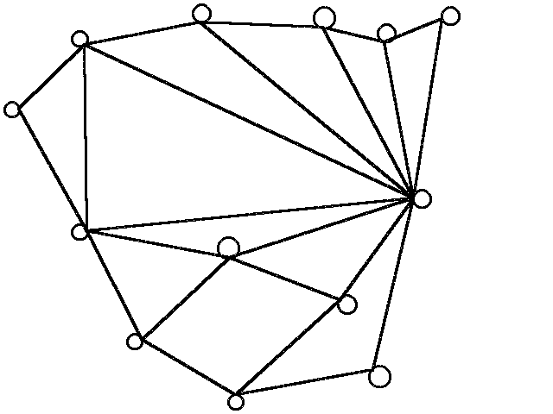

2. Consider the graph below.
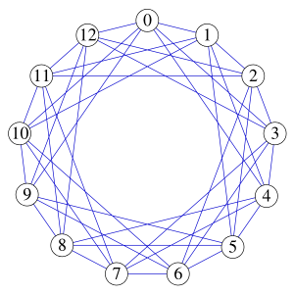
a. Determine if this graph is a complete graph.

b. If it were a complete graph, it would be K₁₃. How many edges would the graph have to have?

c. How many distinct Hamilton circuits would the graph have to have?

d. Does the graph above satisfy Dirac’s theorem?

3. Use the table below to solve the traveling salesman problem (TSP). You are flying out of Buffalo and need to visit each of the following cities in the most efficient way possible. You will need to return to Buffalo to complete the circuit.
 | Buffalo | Chicago | Denver | Memphis | Miami | Omaha | Raleigh
Buffalo | * | 522 | 1508 | 899 | 1409 | 971 | 605
Chicago | 522 | * | 996 | 530 | 1329 | 459 | 784
Denver | 1508 | 996 | * | 1040 | 2037 | 537 | 1661
Memphis | 899 | 530 | 1040 | * | 997 | 652 | 728
Miami | 1409 | 1329 | 2037 | 997 | * | 1641 | 819
Omaha | 971 | 459 | 537 | 652 | 1641 | * | 1214
Raleigh | 605 | 784 | 1661 | 728 | 819 | 1214 | *

a. Which of the methods we learned in the chapter will give you the optimal route?

b. Which method is the most efficient? (why?)

c. Use the Cheapest Link algorithm to find a solution to the TSP. List the Hamilton circuit by the cities you’d travel through in order, and give the number of miles in your final route.

4. Solve the TSP described by the graph below.

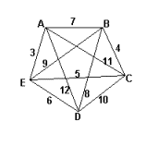
a. Which method are you using?

b. What is the solution to the TSP you propose? Give the order of the vertices you travel through and the weight of the final circuit.

5. Use the graph below and Kruskal’s algorthim to find the minimal spanning tree of the network.

Label the edges of the graph included in the tree, and state the weight of the final tree.

6. Find spanning trees for each of the graphs below. Label the edges included in the tree. State the redundancy of each graph.

a. 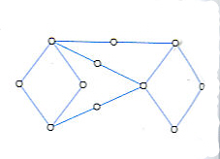 b. 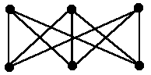

c. 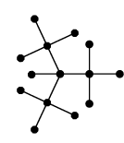 d. 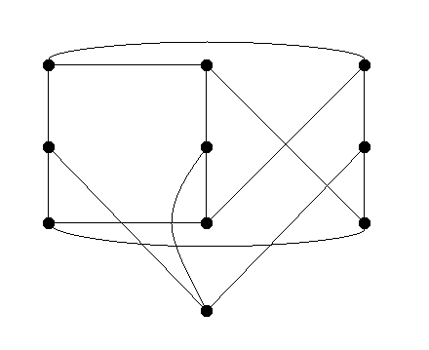

Vocabulary and Short Answers:
7. A complete graph is defined by what property?

8. What is the difference between a Hamilton circuit and a Hamilton path?

9. For TSPs with a large number of vertices, why is it almost impossible to find the optimal solution?

10. Describe the steps in the Repetitive Nearest Neighbor Algorithm. (Assume that the reader knows how to perform the Nearest Neighbor Algorithm.)

11. Explain what the difference is between an optimal algorithm and an efficient one. How does this justify our use of approximate algorithms?

12. What are the three properties of trees?

13. Which method for Hamilton circuits is Kruskal’s Algorithm (for minimal spanning trees) most like? Why might someone conclude that Kruskal’s Algorithm works better?

14. Torricelli’s Construction is used for finding what?

Bonus: What are the conditions for using a MST on a three vertex network? Under what conditions should one look for a Steiner point?

