Name __________________________________________________
Quiz #6, Math 102, Summer 2007

1. Determine the following are functions:
a. {(1,1),(1,2),(1,3),(1,4),(1,5)}

b. x=5

c. 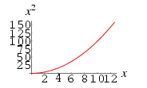

2. State the domain and range of the graph of the circle below. [Note: the coordinates of the graph are given at the left and bottom.]

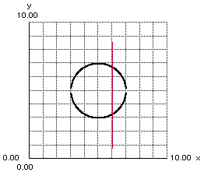

3. If $f(x)=x^{2}+2x−3$, find all the values where f(x)=5.

4. Find the x- and y-intercepts of the line $x−2y=−8$.

