Name _______________________________________________
Quiz #7, Math 102, Summer 2007

1. Graph the linear function $f(x)=\frac{4}{3}x+2$.
2
2. Find the slope of the line that passes through the points (3,-2) and (-1,-6).

m=1

3. Which graph has the bigger slope?
a.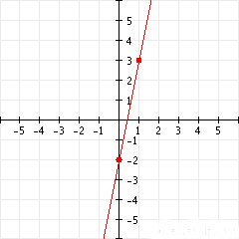 b. 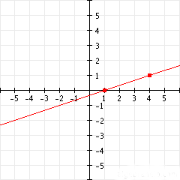 a

4. Determine whether the graphs of the two equations below are parallel, perpendicular or neither.

$\begin{aligned}2x−y=−\text{10} \\ 2x+4y=2\end{aligned}$ perpendicular

