MATH 104 Final Exam Review Key

1. a) $(−∞,−\frac{5}{\text{12}}]$ b) $\left(−∞,−\frac{\text{18}}{\text{17}}\right)$

2. at most 3 hours
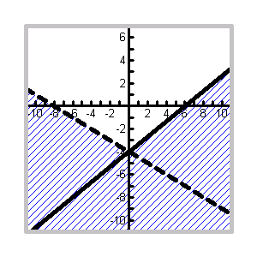
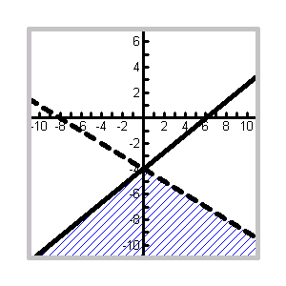
3. a) b)

4. a) $[−\text{11}\text{, }\frac{\text{23}}{2})$ b) $\left(\frac{1}{4}\text{, 4}\right)$

5. a) $\left[−5, 7\right]$ b) $(−∞, −4] ∪ [3, ∞)$ c) ∅ d) $\left(−∞, ∞\right)$

6. a) $\left[−\frac{\text{11}}{3}, \frac{\text{19}}{3}\right]$ b) $\left(\frac{1}{3}, \frac{7}{3}\right)$ c) $x=−\frac{1}{3}$ or $x=−3$ d) $\left(−∞, −1\right)∪\left(\frac{\text{11}}{5}, ∞\right)$ e) $\left(−∞, ∞\right)$ f) ∅

7. $(−∞, −4] ∪ [ 1, ∞)$ 8. a) no solution b) a = -3 c) x = -5 9. $a = \frac{2b}{3b−4}$

10. The speed of the express bus is 42 mph and the speed of the local bus is 35 mph.

11. 9.9 miles 12. 7.2 hours 13. a) $\frac{1}{4}$ b) 8

14. a) domain = $[−3, ∞)$, range = $[−2, ∞)$ b) domain = $\left(−∞, ∞\right)$, range = $\left(−∞, ∞\right)$
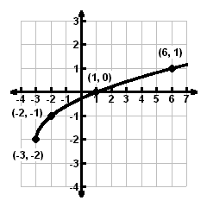
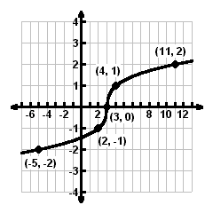

15. a) $\frac{3x^{\frac{\text{10}}{3}}}{y^{3}}$ or $\frac{3x^{3} \sqrt[3]{x}}{y^{3}}$ b) $\frac{x^{4} \sqrt{x}}{8}$ 16. a) $\text{13}\sqrt{5x}$ b) $6\sqrt{\text{15}}−2\sqrt{\text{30}}$
17. a) $\frac{\sqrt{\text{10}}}{4}$ b) $\frac{x+4\sqrt{x}−\text{21}}{x−9}$
18. Rational and Radical equations could have extraneous solution.
For rational equations, check to see if the solution obtained causes any of the denominators of the original
equation to be zero. If yes, then the solution is extraneous.
For radical equations, the potential solutions must be substituted into the original equation and the equality
should be tested numerically.
In both cases, a graphical check using the original equation would also serve to expose extraneous
solutions.

19. a) $−2+2i$ b) $6+2i$ c) $\text{24}+\text{10}i$

20. a) no solution b) x = 2 c) x = 0, $\frac{2}{3}$ d) $x=−1±\sqrt{5}$
e) $x=−\frac{1}{8} ± \frac{\sqrt{\text{143}}}{8}i$ f) x = 27, $−\frac{1}{8}$ g) $a=±2, ±\sqrt{3}$ h) $a=±2i, ±i\sqrt{3}$

21. exact: $\left(2+\sqrt{\text{46}}\right)$ feet approximate: 8.78 feet 22. 8.53 hours 23. $\left[−5, \frac{3}{2}\right] ∪ [4, ∞)$
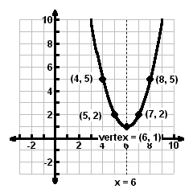
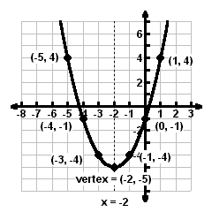
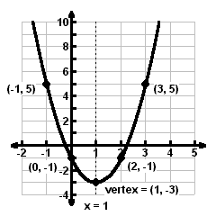
24. a) b) c)

25. a) $f(x)={\left(x−3\right)}^{2}+1$, vertex = (3, 1) b) $f(x)=−3{\left(x−1\right)}^{2}+7$, vertex = (1, 7)
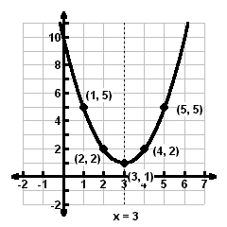
y-int. = $\left(0, \text{10}\right)$, no x-int. y-int. = $\left(0, 4\right)$, x-int. = $\frac{3±\sqrt{\text{21}}}{3}$
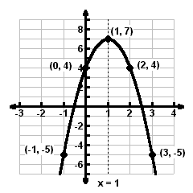

26. 3 seconds, 144 feet

27. a) quadratic b) $y= 0\text{.}\text{034}x^{2}−0\text{.}\text{563}x+\text{16}\text{.}\text{784}$ c) 18.26 births per thousand people

