STAT 1350: Elementary Statistics
Lab Activity #10 Name(s)_________________________
Descriptive Statistics - Graphs Date ___________________________

In this lab, we will investigate how changing the size and number of the classes changes the shape of the histogram and stem and leaf plot. We will also draw appropriate graphs for our class survey data.

I selected a random sample of 30 individuals who completed the Class Survey at the beginning of the semester and recorded their heights (in inches). Make a stem and leaf of the Height data below.
Height of Stat 1350 students (in inches)
66 72 62 72 74 64 66 66 62 66 66 67
66 64 65 64 69 55 71 67 67 71 65 62
71 60 65 72 67 69

|
|
|
|
|
|
|

Next, enter the data from the stem and leaf in column L1 on your calculator by going to STAT, then #1 Edit.
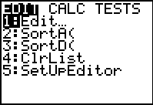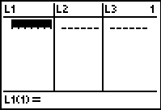

To draw a histogram, go to the STAT PLOT menu on your calculator by pressing the 2nd key then the Y= key. Press enter to set up Plot1 as shown in the second screen below:

Now press the ZOOM key and select 9:ZoomStat. Draw the Histogram on the second screen below:

Now press the WINDOW key and change the Xscl value to 5. Then press the GRAPH key. Draw the Histogram on the second screen below:

Now press the WINDOW key and change the Xscl value to 2. Then press the GRAPH key. Draw the Histogram on the second screen below:
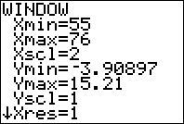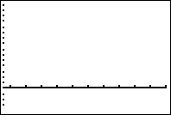

Questions:

- What is the shape of the first histogram ? How does the shape of the histogram compare to the shape of the stem and leaf? Explain.

- What happened to the histogram when you changed the class width to 5? Did the shape of the histogram change? Explain.

- What happened to the histogram when you changed the class width to 2? Did the shape of the histogram change? Explain.

- Which histogram gives the best picture of the shape of the distribution of heights? Explain.

Other Graphs

I selected a random sample of 10 individuals who completed the Class Survey at the beginning of the semester and recorded their gender.

Male Female Female Male Male
Female Female Female Female Female

What type of data is this? _________________________________

Make an appropriate graph of this data and explain what it reveals.

Graphs – Good and Bad

Is the graph below a good graph or a bad graph? Justify your answer.

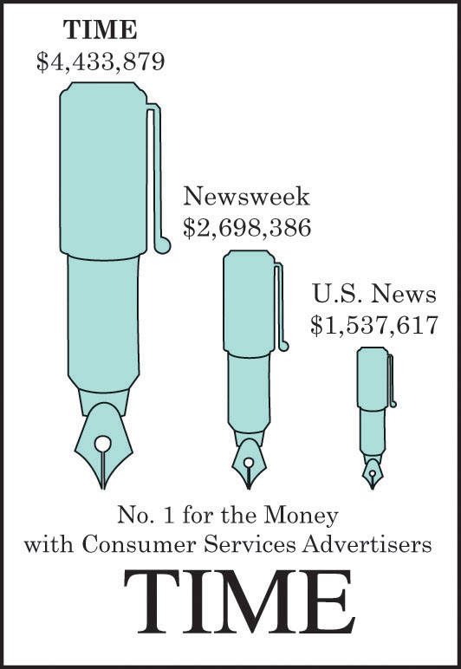

Is the graph below a good graph or a bad graph? Justify your answer.

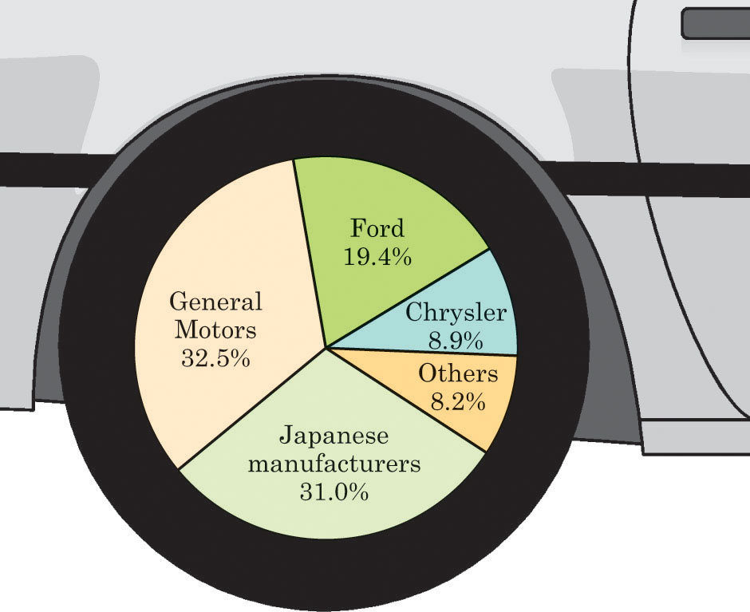
Passenger car sales by several manufacturers in 1997.

