STAT 1350: Elementary Statistics
Lab Activity #12 Name(s)_________________________
Descriptive Statistics Date ___________________________

In this lab, we will investigate how adding, subtracting, multiplying and dividing a constant to a set of data impacts the mean, median, and standard deviation.

To begin, collect a sample of 5 ages from your class and enter them in the first column of the table below. Next, we will add, subtract, multiply, and divide a constant (10) to the original data. We have arbitrarily chosen the constant 10. Record these values in the table below.

Next, enter the data from your table in column L1-L5 on your calculator by going to STAT, then #1 Edit.

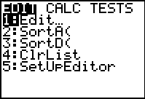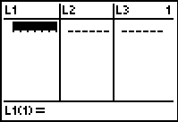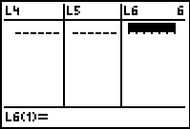

Calculate the mean, median, and standard deviation on the graphing calculator by going to STAT, then CALC, then #1 1VARSTATS. Enter the appropriate column (L1, L2, L3, L4, or L5) and hit enter. Record the values of the mean, median, and standard deviation in the table below.

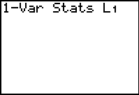

 | L1: Age | L2: Age + 10 | L3: Age - 10 | L4: Age * 10 | L5: Age /10
Mean
Median
Standard Deviation
Questions:

- What happened to the mean, median, and standard deviation when you added 10 to the original data? Explain.

- What happened to the mean, median, and standard deviation when you subtracted 10 to the original data? Explain.

- What happened to the mean, median, and standard deviation when you multiplied the original data by 10? Explain.

- What happened to the mean, median, and standard deviation when you divided the original data by 10? Explain.

Summary:

Fill in the blanks.

Adding or subtracting a constant to the original data will move the _______________ and ______________ up or down the same number of units as the constant, but the ____________________ remains the same.

Multiplying the original data by a constant will cause the _______________, _______________, and __________________ to be multiplied by the same constant.

Dividing the original data by a constant will cause the _______________, _______________, and __________________ to be divided by the same constant.

