STAT 1350: Elementary Statistics
Lab Activity #17 Name(s)_________________________
Simulation/Law of Large Numbers Date ___________________________

Let’s use our TI calculator to simulate the tossing of a two-sided coin.

First you will need to seed the random number generator of your calculator with your birthdate. Enter your birth month and day as a 4 digit number on your calculator. Press the STO key then press the MATH key and arrow over to the PRB menu. Select 1: rand and press ENTER. For example, my birthday is December 28th so my calculator screen would look like this:
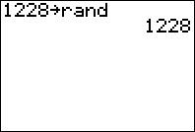

Press the APPS key and then the Prob Sim (this is the TI probability simulator). This application may located in another location with newer TI calculators. Then select 1. Toss Coins
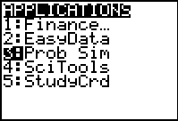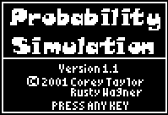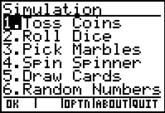

Then select TABL (press the GRAPH key). This is the screen that should appear:
Now select TOSS (press the WINDOW key) to simulate one toss of a two-sided coin.

The table keeps a running total of the tosses as well as the cumulative number of heads. Continue to select TOSS simulate the tossing of a two-sided coin for the number of tosses outlined in the table below. Note: You can press the ZOOM button to increase the number of tosses by 10 or the TRACE button to increase the number of tosses by 50. Record the data in the table below (Round the probabilities to three decimal places):
Number of Tosses | 10 | 20 | 50 | 100 | 200 | 300 | 400 | 500
Number of Heads
Probability of Head
Questions:
- Are the outcomes of tossing a two-sided coin independent? Why or why not?

- Now, thinking about tossing a two-sided coin, what is the long-run probability of tossing a head?

- What do you notice about the calculated probabilities as you read the third row of the table from left to right? Describe the trend you see.

- How does the Law of Large Numbers explain this observation?

Graph of Results
To graph the results, we first have to enter data into lists. The TI-83 has six columns (called lists L₁, L₂, L₃, L₄, L₅, and L₆) in which data can be entered.

Press the STAT key and then select 1:Edit. You will now the data screen with the six lists, L₁ through L₆ (use your right arrow to see L₄ through L₆).

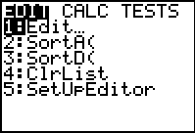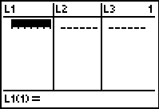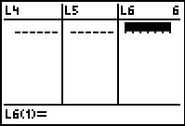
Enter the number of tosses row from the table in list L₁ and the probability of head row from the table in list L₂.
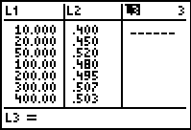
Next press the Y= button and enter .5 into Y₁.
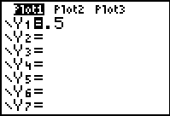
The next step is to select a line graph for the plot. Press 2nd [STAT PLOT]. Highlight Plot1 and press ENTER.
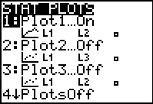

Then on the next screen highlight ON and hit ENTER then highlight the line graph (middle graph top row), hit ENTER. For XList use L₁ and YList use L₂. For Mark select the box (first choice).
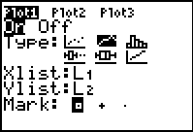

Press ZOOM > 9: ZoomStat. Use TRACE to sketch your line graph here* (*Good graphs should have a title, both axes should also have a title, both axes should have clearly marked scales!)

Questions on the Graph of Results
- What does the horizontal line on the graph represent?

- What does the line that moves up and down represent?

- How does the graph you sketched above relate to the Law of Large Numbers?

