STAT 1350: Elementary Statistics Names:
Lab Activity #2
Statistical Scavenger Hunt I

The Gallup Organization (www.gallup.com) provides data on all aspects of the attitudes and lifestyles of people around the world. Gallup is just one of many organizations who try to determine what the public is thinking by conducting scientific polls. Try to find a report at Gallup or any other opinion poll source that lists as much information as possible.

- What is the title and source of the report you found?

- For the report you found of a poll, answer all the questions below that are addressed in your article. The report you find must provide answers to at least five of the eight questions.

  - Who carried out the survey?

  - What was the population of interest? What in the article indicated this as a population of interest?

  - How was the sample selected?

  - How large was the sample?

  - How were the subjects contacted?

  - When was the survey conducted?

  - What were the exact questions asked?

- Carefully describe the parameter of interest in the poll you found.

- Did any of the questions above help you find a source of bias in the conclusions of the report?

- Do any of the questions above that were not addressed in the article give you concern about other potential sources of bias in the conclusions of the report? Explain.

- Does the article present a margin of error that is associated with the poll? If so, what is it? Does it present the sample size?

- After all margin of errors and sample sizes are listed on the board, record them here.

Margin of error | Sample size

- Examine the relationship between the sample size and the margin of error. As the sample size increases, does the margin of error increase or decrease?

GROUP 1:

January 11, 2013

U.S. Flu Reports in December Higher Than in Prior Years

3.2% reported having flu the prior day
by Alyssa Brown
WASHINGTON, D.C. -- Americans' self-reports of the flu spiked early this season, rising in December to levels typically not seen until February. An average of 3.2% of Americans reported having the flu the day before they were surveyed in December. This is higher than what Gallup found in the same month in any past year since it started tracking flu daily in 2008.
Self-reports of the flu peaked in February in three of the last four flu seasons -- with an average of 3.3% saying they had the flu "yesterday" in the 2008-2009 and the 2010-2011 seasons, and an average of 3.0% reporting having the flu "yesterday" in the 2011-2012 season. The only time this pattern did not occur was during the 2009-2010 season, when the flu peaked in October amid the outbreak of the H1N1 flu virus. This early rise in Americans' self-reports of the flu in December suggests that the peak of the 2012-2013 flu season may be worse than the previous four seasons.
The Centers for Disease Control and Prevention, which tracks clinically confirmed influenza through collaborating laboratories in all 50 states and the District of Columbia, has reported similar trends. The CDC announced that the percentage of people visiting their healthcare provider for flu-like illnesses significantly increased to 5.6% in the last week of December, up from 2.8% during the first week of the month.
The Gallup-Healthways Well-Being Index asks 1,000 Americans each day whether they had a cold or the flu "yesterday." It is possible that the average of daily cold and flu prevalence is underestimated because those who were sick the day before may be less likely to respond to a phone survey than those who were not sick. Still, the opportunity for year-over-year comparisons with data from previous cold and flu seasons provides useful insights into their respective changes over time.
Flu, Cold Rates Highest Among Hispanics and Those With Lower Incomes, as Is Typical
Hispanics, as is usually the case, were by far the most likely to report having the flu (9.2%) or a cold (12.0%) on any given day in December. Low-income Americans -- along with smokers and those with asthma -- also reported among the highest flu and cold rates in the country last month.
Americans aged 30 to 44 were the age group most likely to report the flu in December. This is atypical, as reports of the flu generally decline with age, with those aged 18 to 29 usually reporting the most cases.
Women were slightly more likely than men to report having these illnesses in December.
Daily reports of the flu were highest in the East and West, while reports of colds were highest in the East and South.
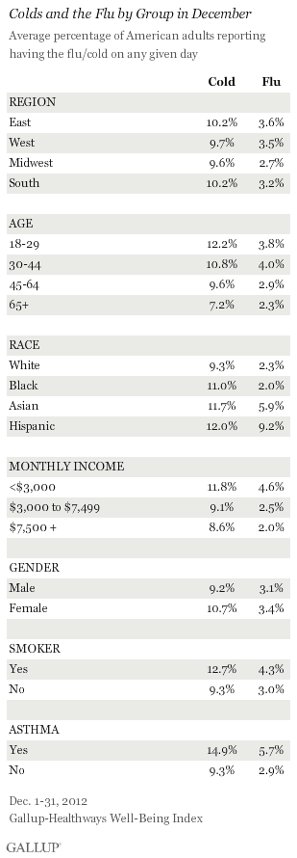
Bottom Line
After typical levels in the early months of the flu season, Americans' average daily reports of the flu sharply increased in December, exceeding rates found in the same month in previous years. Americans' self-reports of the flu this December match levels typically seen during the peak of flu season in January and February.
The mayor of Boston declared a public health emergency after the city experienced a surge in the number flu cases, and the national media is covering this flu season extensively. The recent increase in publicity surrounding higher-than-average flu levels may encourage more Americans to get the flu vaccine, practice healthy behaviors, and stay home when they suspect they have the flu. These actions could prevent further spikes in reports of the flu and colds in the typical peak months and reduce the severity of the influenza virus for those who are most at risk. Gallup will continue to track self-reported cold and flu cases throughout the 2012-2013 season.
About the Gallup-Healthways Well-Being Index
The Gallup-Healthways Well-Being Index tracks wellbeing in the U.S. and provides best-in-class solutions for a healthier world. To learn more, please visit well-beingindex.com.
Survey Methods
Results are based on telephone interviews conducted as part of the Gallup Healthways Well-Being Index survey Dec. 1-31, 2012, with a random sample of 27,300 adults, aged 18 and older, living in all 50 U.S. states and the District of Columbia.
For results based on the total sample of national adults, one can say with 95% confidence that the maximum margin of sampling error is ±1 percentage point.
Interviews are conducted with respondents on landline telephones and cellular phones, with interviews conducted in Spanish for respondents who are primarily Spanish-speaking. Each sample includes a minimum quota of 400 cellphone respondents and 600 landline respondents per 1,000 national adults, with additional minimum quotas among landline respondents for gender within region. Landline telephone numbers are chosen at random among listed telephone numbers. Cellphone numbers are selected using random digit dial methods. Landline respondents are chosen at random within each household on the basis of which member had the most recent birthday.
Samples are weighted by gender, age, race, Hispanic ethnicity, education, region, adults in the household, and phone status (cellphone-only/landline only/both, cellphone mostly, and having an unlisted landline number). Demographic weighting targets are based on the March 2011 Current Population Survey figures for the aged 18 and older non-institutionalized population living in U.S. telephone households. All reported margins of sampling error include the computed design effects for weighting and sample design.
In addition to sampling error, question wording and practical difficulties in conducting surveys can introduce error or bias into the findings of public opinion polls.
For more details on Gallup's polling methodology, visit www.gallup.com.
GROUP 2:

January 10, 2013

In U.S., Rise in Religious "Nones" Slows in 2012

The 17.8% who reported no religious identity in 2012 is on par with 2011
PRINCETON, NJ -- The percentage of American adults who have no explicit religious identification averaged 17.8% in 2012, up from 14.6% in 2008 -- but only slightly higher than the 17.5% in 2011. The 2011 to 2012 uptick in religious "nones" is the smallest such year-to-year increase over the past five years of Gallup Daily tracking of religion in America.
To measure religious identity, Gallup asks respondents this question:
What is your religious preference -- are you Protestant, Roman Catholic, Mormon, Jewish, Muslim, another religion, or no religion? (If respondent names "another religion," ask:) Would that be a Christian religion or is it not a Christian religion?
Religious "nones" are those who respond "no religion" as well as those who say they don't know or refuse to answer.
The rise in the religious "nones" over time is one of the most significant trends in religious measurement in the United States. Virtually all Americans in Gallup surveys conducted in the 1950s and 1960s -- albeit in response to somewhat different types of questions -- had a religious identity. The percentage who did not report such an identity began to rise in the 1970s and has continued to increase in the years since.
Gallup Daily tracking, which started in 2008, encompasses about 350,000 interviews a year, and each of those interviews includes the question about religious identity. These unprecedented large samples produce annual estimates with very low margins of error, and thus the ability to look at year-to-year trends in granular detail.
Across the past five years, the biggest jumps in "nones" occurred between 2009 and 2010 and between 2010 and 2011 -- an increase of 1.1 percentage points each between the two years. In absolute terms, 15.3% of the population had no explicit religious identity in 2009, compared with 17.5% in 2011.
The rate of change between 2011 and 2012, however, slowed to a 0.3-point increase -- from 17.5% to 17.8%. These estimates are based on 353,492 interviews in 2011 and 353,571 interviews in 2012.
It is not clear what this slowed rate of change in no religious identity is attributable to, or if it signifies a lasting shift in the trend. There are a number of broad changes taking place in American society, including the inexorable aging of the huge baby boom generation born between 1946 and 1964, the ebbs and flows of the economy, changes in demographic patterns of immigration, migration among states, fertility, and marriage, and more abstract changes in the culture. All of these patterns are related to religion in some way.
Asians, Young Adults, Those in the Pacific Region Most Likely to Be "Nones"
Religious "nones" differ from those who do have a religious identity in a number of ways, as detailed in the book God Is Alive and Well.
Those most likely to be "nones" include Asians, young people, those living in the Pacific and New England regions, political independents, and men. Those least likely to be "nones" include Republicans, older Americans, those living in the South, blacks, women, and Hispanics. These demographic and socioeconomic differences are consistent with other general measures of religiosity.
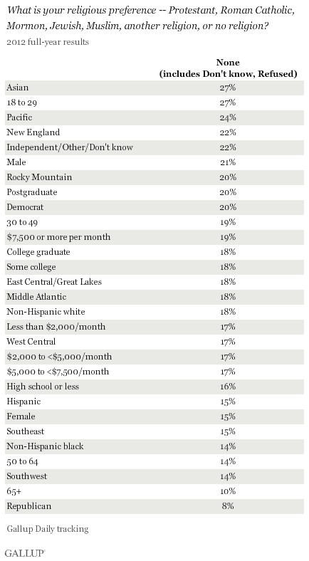

Bottom Line
Americans' expression of an explicit religious identity in response to a survey interviewer's question is one of many measures of religiosity, although by no means a definitive measure of a person's religiousness or spirituality. The rise in "nones" partly reflects changes in the general pattern of expression of religion in American society today -- particularly including trends towards more "unbranded," casual, informal religion. And, although this "rise of the nones" has increased dramatically over recent decades, the rate of increase slowed last year, suggesting the possibility that there may be a leveling off in this measure in the years ahead.
Survey Methods
Results are based on telephone interviews conducted as part of Gallup Daily tracking from 2008 through 2012, with random samples of 311,588 adults, aged 18 and older, living in all 50 U.S. states and the District of Columbia in 2008, 353,849 adults in 2009, 352,842 adults in 2010, 353,492 adults in 2011, and 353,571 adults in 2012.
For results based on the total sample of national adults for each year, one can say with 95% confidence that the maximum margin of sampling error is ±0.5 percentage point.
Interviews are conducted with respondents on landline telephones and cellular phones, with interviews conducted in Spanish for respondents who are primarily Spanish-speaking. Each sample includes a minimum quota of 400 cellphone respondents and 600 landline respondents per 1,000 national adults, with additional minimum quotas among landline respondents by region. Landline telephone numbers are chosen at random among listed telephone numbers. Cellphone numbers are selected using random-digit-dial methods. Landline respondents are chosen at random within each household on the basis of which member had the most recent birthday.
Samples are weighted by gender, age, race, Hispanic ethnicity, education, region, adults in the household, and phone status (cellphone only/landline only/both, cellphone mostly, and having an unlisted landline number). Demographic weighting targets are based on the March 2011 Current Population Survey figures for the aged 18 and older non-institutionalized population living in U.S. telephone households. All reported margins of sampling error include the computed design effects for weighting and sample design.
In addition to sampling error, question wording and practical difficulties in conducting surveys can introduce error or bias into the findings of public opinion polls.
For more details on Gallup's polling methodology, visit www.gallup.com.
GROUP 3:

January 10, 2013

U.S. Satisfaction Improved in 2012, but Still Below Average

Twenty-six percent satisfied with how things are going in the country
by Jeffrey M. Jones
PRINCETON, NJ -- An average of 26% of Americans said they were satisfied with the way things were going in the United States in 2012, an improvement from 17% in 2011. Still, satisfaction remains depressed compared with the historical average of 38%.
The 2011 average of 17% satisfaction was one of the lowest in Gallup records dating back to 1979, with only a 15% average from 2008 lower. The highest yearly averages were 60% in 1998 and 2000. Satisfaction has averaged below 30% each year since 2007.
Gallup asks Americans about satisfaction monthly and reported 14 separate measurements in 2012, ranging from a low of 18% in January to a high of 33% in November. Satisfaction had generally shown improvement, particularly in the fall months when it was at or exceeded 30% from September through mid-November, before falling back to 23% in December.
On average, Democrats (43%) were much more satisfied than Republicans (9%) or independents (23%) in 2012. Democratic satisfaction averaged an even higher 55% from September through November, coinciding with President Obama's fall re-election campaign.
Democrats were primarily responsible for the increase in satisfaction from 2011 to 2012, but independents were also modestly more satisfied.
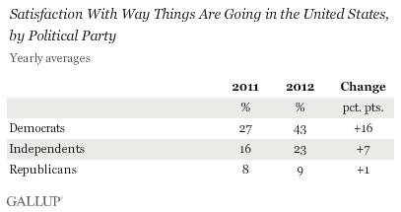
One major reason satisfaction likely improved from 2011 to 2012 was Americans' more positive assessment of the national economy. Gallup's Economic Confidence Index also showed significant improvement in 2012 compared with 2011.
Implications
Americans were a bit more positive about national conditions in 2012 than they were in 2011, though on an absolute basis still not very satisfied. Satisfaction has been in a slump for several years now, with levels below the historical average each of the last seven years. This, however, did not prevent President Obama from being re-elected, with the lowest average satisfaction level in a year an incumbent successfully won re-election.
One key to breaking out of that slump is to sustain some positive momentum in satisfaction. After dropping to a historical low of 15% in 2008, satisfaction rebounded to 27% in 2009, President Obama's first year in office. But satisfaction declined in both of the following years, before improving again last year.
Perceptions of national economic conditions will be an important factor in determining whether satisfaction continues to improve in 2013. The economy has certainly improved in many respects compared with the 2008-2009 recession, but some aspects of the economy, such as unemployment, remain problematic and serve as a drag on Americans' mood.
Survey Methods
Results for this Gallup poll are based on telephone interviews conducted in 14 separate Gallup polls January-December 2012, each with a random sample of approximately 1,000 adults, aged 18 and older, living in all 50 U.S. states and the District of Columbia, selected using random-digit-dial sampling.
For results based on the total combined sample of national adults, one can say with 95% confidence that the maximum margin of sampling error is ±4.5 percentage point.
Interviews are conducted with respondents on landline telephones and cellular phones, with interviews conducted in Spanish for respondents who are primarily Spanish-speaking. Each sample includes a minimum quota of 400 cellphone respondents and 600 landline respondents per 1,000 national adults, with additional minimum quotas among landline respondents by region. Landline telephone numbers are chosen at random among listed telephone numbers. Cellphone numbers are selected using random-digit-dial methods. Landline respondents are chosen at random within each household on the basis of which member had the most recent birthday.
Samples are weighted by gender, age, race, Hispanic ethnicity, education, region, adults in the household, and phone status (cellphone only/landline only/both, cellphone mostly, and having an unlisted landline number). Demographic weighting targets are based on the March 2011 Current Population Survey figures for the aged 18 and older non-institutionalized population living in U.S. telephone households. All reported margins of sampling error include the computed design effects for weighting and sample design.
In addition to sampling error, question wording and practical difficulties in conducting surveys can introduce error or bias into the findings of public opinion polls.
For more details on Gallup's polling methodology, visit http://www.gallup.com/.
GROUP 4:

December 27, 2012

Americans Want Stricter Gun Laws, Still Oppose Bans

Support for strengthening gun sale laws has surged 15 percentage points since 2011
by Lydia Saad
PRINCETON, NJ -- In the aftermath of the Sandy Hook Elementary School shooting in Newtown, Conn., Gallup finds 58% of Americans in favor of strengthening the laws covering the sale of firearms, up from 43% in 2011. Current support for stricter gun laws is the highest Gallup has measured since January 2004, but still not nearly as high as it was in the 1990s.
These results are from a USA Today/Gallup poll conducted Dec. 19-22, just days after the Newtown tragedy. Gallup's prior measure of Americans' attitudes toward new gun laws was conducted in October 2011. Since then, there have been several other mass shootings in the U.S., including one in July at a Colorado movie theater that left 12 dead and more than 50 wounded. More recently, a gunman killed his boss and four others at a factory in Minneapolis in September, and in August a U.S. Army veteran opened fire in a Sikh temple in Wisconsin, killing six.
Perhaps as a result of these events, the new poll also finds that a record-high 47% of Americans favor passing new gun laws, up from 35% in 2011. Since Gallup first asked this question in 2000, majorities have consistently preferred enforcing the current laws more strictly without passing new laws.
Opponents of Assault Rifle Ban Still Outnumber Proponents
Two aspects of the Newtown shooting that have been a focal point of recent discussions about gun laws are the semi-automatic rifle and high-capacity ammunition magazines used by the shooter. Several state and federal lawmakers have already announced that they will seek to ban both from the commercial market.
Nevertheless, Americans' views on the sale of assault rifles are unchanged. The slight majority, 51%, remain opposed to making it illegal to manufacture, sell, or possess semi-automatic guns known as assault rifles.
Notably, the 44% in favor of assault rifle bans in response to this trend question is nearly identical to the 42% Gallup found favoring assault and semi-automatic bans in a Dec. 18 poll. In that survey, participants responded to a question asking about possible approaches to preventing mass shootings at schools, similar to the shooting that occurred Dec. 14 in Connecticut.
Americans Favor Limits on Gun Show Sales and High-Capacity Magazines
A significantly higher percentage of Americans -- 62% -- do favor banning the sale of high-capacity ammunition magazines, generally defined as those that contain more than 10 rounds. Also, nearly all Americans -- now 92%, up from 83% in 1999 -- favor laws that require people attempting to purchase guns at gun shows, including gun dealers, to undergo background checks.
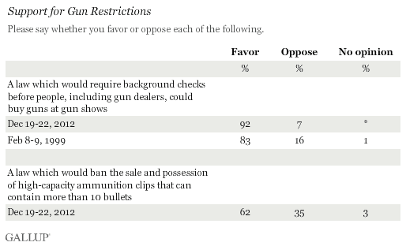
Opposition to Handgun Ban Hits Record-High 74%
Despite Americans' willingness to strengthen gun laws in the wake of Sandy Hook and other deadly mass shootings, Gallup finds public opposition to a broad ban on the possession of handguns at a record-high 74%. Conversely, the 24% in favor is the lowest recorded since Gallup first asked the question in 1959.
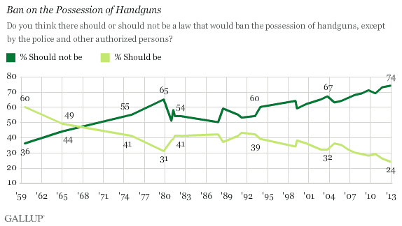
Bottom Line
Americans favor new legislation to limit gun sales, presumably to help prevent the kind of gun violence that became all too familiar in 2012. This is seen in increased support for making the laws covering the sale of firearms more strict, and for passing new gun laws. However, views toward banning semi-automatic guns or assault rifles are unchanged, and -- possibly reflecting Americans' desire to defend themselves given the rash of high-profile gun violence -- a record-high 74% oppose preventing anyone but the police or other authorized officials from owning a handgun.
Survey Methods
Results for this USA Today/Gallup poll are based on telephone interviews conducted Dec. 19-22, 2012, with a random sample of 1,038 adults, aged 18 and older, living in all 50 U.S. states and the District of Columbia.
For results based on the total sample of national adults, one can say with 95% confidence that the maximum margin of sampling error is ±4 percentage points.
Interviews are conducted with respondents on landline telephones and cellular phones, with interviews conducted in Spanish for respondents who are primarily Spanish-speaking. Each sample includes a minimum quota of 400 cellphone respondents and 600 landline respondents per 1,000 national adults, with additional minimum quotas among landline respondents by region. Landline telephone numbers are chosen at random among listed telephone numbers. Cellphone numbers are selected using random-digit-dial methods. Landline respondents are chosen at random within each household on the basis of which member had the most recent birthday.
Samples are weighted by gender, age, race, Hispanic ethnicity, education, region, adults in the household, population density, and phone status (cellphone only/landline only/both, cellphone mostly, and having an unlisted landline number). Demographic weighting targets are based on the March 2011 Current Population Survey figures for the aged 18 and older U.S. population. All reported margins of sampling error include the computed design effects for weighting.
In addition to sampling error, question wording and practical difficulties in conducting surveys can introduce error or bias into the findings of public opinion polls.
View methodology, full question results, and trend data.
For more details on Gallup's polling methodology, visit http://www.gallup.com/.
GROUP 5:

January 8, 2013

U.S. Economic Confidence Remains Low Post-Fiscal Cliff Deal

Americans less confident in both current conditions and future outlook
by Elizabeth Mendes
WASHINGTON, D.C. -- Gallup's U.S. Economic Confidence Index was -21 for the week ending Jan. 6, similar to the -22 in the week prior. Americans' confidence in the economy has worsened amid the fiscal cliff debate after improving in November.
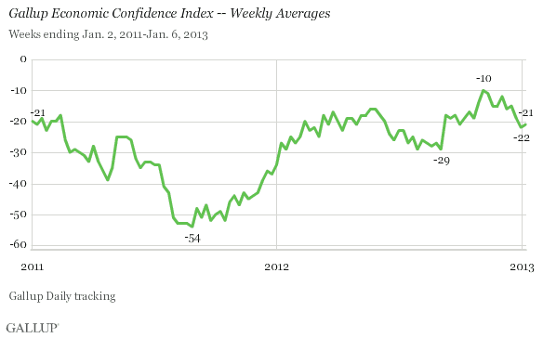
Last week's reading encompasses the days during which lawmakers reached a final agreement on resolving the fiscal cliff, culminating in President Obama's signing the bill on Wednesday, Jan. 2. Americans' confidence in the economy climbed to a four-year high in November, before uncertainty surrounding the fiscal cliff apparently caused it to worsen. Although down, confidence has not dropped nearly as low as the August 2011 weekly reading of -54, which came in the aftermath of the debt ceiling debate.
Americans' lower economic confidence is due to worsening views of current conditions and a souring outlook for the future. The -18 economic outlook rating is down significantly from -1 in early November, with 39% of Americans now saying the economy is getting better and 57% saying it is getting worse.
Sixteen percent of Americans say the economy is excellent or good and 40% say it is poor, resulting in a -24 current conditions rating, down from -18 in early November.
Bottom Line
As lawmakers in Washington strained to finalize a deal to avert the fiscal cliff, Americans became less confident in the economy. And their confidence remains lower even after Congress passed and President Obama signed into law a bill that successfully staved off the fiscal cliff. Now that the deal is done, it is possible that Americans will start to feel better about the economy in the days and weeks ahead. However, lingering concerns could keep confidence from improving much, as happened in September and October 2011, after the debt ceiling debate.
Survey Methods
Results are based on telephone interviews conducted as part of Gallup Daily tracking Dec. 31, 2012-Jan. 6, 2013, with a random sample of 2,043 adults, aged 18 and older, living in all 50 U.S. states and the District of Columbia.
For results based on the total sample of national adults, one can say with 95% confidence that the maximum margin of sampling error is ±3 percentage points.
Interviews are conducted with respondents on landline telephones and cellular phones, with interviews conducted in Spanish for respondents who are primarily Spanish-speaking. Each sample includes a minimum quota of 400 cellphone respondents and 600 landline respondents per 1,000 national adults, with additional minimum quotas among landline respondents by region. Landline telephone numbers are chosen at random among listed telephone numbers. Cellphone numbers are selected using random-digit-dial methods. Landline respondents are chosen at random within each household on the basis of which member had the most recent birthday.
Samples are weighted by gender, age, race, Hispanic ethnicity, education, region, adults in the household, and phone status (cellphone only/landline only/both, cellphone mostly, and having an unlisted landline number). Demographic weighting targets are based on the March 2011 Current Population Survey figures for the aged 18 and older non-institutionalized population living in U.S. telephone households. All reported margins of sampling error include the computed design effects for weighting and sample design.
In addition to sampling error, question wording and practical difficulties in conducting surveys can introduce error or bias into the findings of public opinion polls.
For more details on Gallup's polling methodology, visit www.gallup.com.

GROUP 6:

January 2, 2013

Americans Unsure if Best Times for U.S. Are Past or to Come

Many predict 2013 will be a year of difficulty
by Frank Newport
PRINCETON, NJ -- Americans are split when asked if the country's best years are ahead of us or behind us, with views on the future quite differentiated across party lines. Republicans are much more pessimistic about the future of the country than are Democrats.
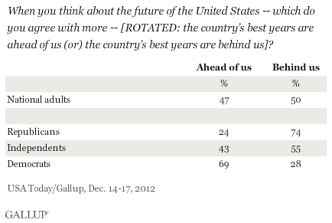
These sentiments, measured in a Dec. 14-17 USA Today/Gallup poll, come at the end of a tumultuous political and economic year -- one which included a contentious presidential election, continuing sparring over the nation's economic policies, and the prospect of dramatic tax increases and government spending cuts as elected leaders argued over avoiding the "fiscal cliff" at year's end. The finding that Democrats are much more positive than Republicans about the future of the U.S. most likely reflects the fact that Democrats control the White House; Democrats are also currently much more positive about the status of the U.S. economy.
The same poll included several questions asking Americans to predict what the year 2013 will bring on economic, governmental, social, and international fronts.
Three of these questions focused on the economy, with results showing mixed predictions about the nation's economic state in 2013. Americans believe by almost a 2-1 margin that 2013 will be a year of economic difficulty rather than a year of prosperity. At the same time, they tilt toward the belief that 2013 will be a year of full or increasing employment rather than a year of rising unemployment. Americans also believe that 2013 will be a year in which prices will rise at a reasonable rate rather than at a high rate.
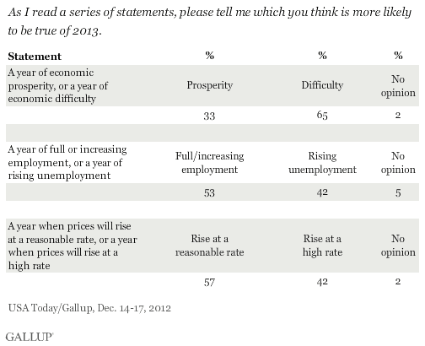
The 65% of Americans who predict 2013 will be a year of economic difficulty is one of the more negative responses to this question since Gallup first asked it in 1965. There has been, however, a great deal of fluctuation over that time period, from a high of 65% who said 1965 would be a year of prosperity, to a low of 7% who predicted 1974 would be a year of prosperity. A majority of Americans were positive about the economy in 1998 and 1999, while swinging more to the "economic difficulty" side of the ledger when asked about 2005.
The slight majority who predict 2013 will be a year of full or increasing employment is not as positive as measured during the dot-com boom in 1998 and 1999, but significantly more positive than readings on this measure throughout the 1970s and in 1980. Americans tended to be more positive about employment in the 1960s, with an all-time high of 67% who said 1966 would be a year of full or increasing employment. Americans were most negative about 1975: 6% predicted that year would be one of full or increasing employment.
Gallup has asked about prices in the coming year only three times, in 2012, 1999, and 1998. In all three years, a majority of Americans said prices would rise at a reasonable rate, but last year's 57% is below the other two measures.
Americans Expect Higher Taxes, Continued Budget Deficit
Americans have strong opinions about two economic issues relating to government policies, with overwhelming majorities believing taxes will rise rather than fall in 2013 and the federal government will continue to have a budget deficit.
The perception that taxes will rise is not new; a substantial majority has predicted this state of affairs in each of the nine years Gallup asked this question. In fact, last year's 82% who predict rising taxes is significantly lower than the 91% and 94% who said taxes would rise in 1967 and 1968, respectively. Even in a time of predicted prosperity, 1998, 62% said taxes would rise.
Eighty-five percent of Americans say there will be a federal government budget deficit in 2013. It would be difficult to find an expert who predicts the budget will be balanced in 2013, making it perhaps surprising that 13% of Americans hold out the belief that the budget will be generally balanced this year. Half of Americans predicted the federal budget would be balanced in 1999 -- a year in which the federal budget actually was in the black.
Americans Expect Global Discord, Waning U.S. Power
Americans are pessimistic about the state of the world in 2013, with a majority saying this year will be a troubled year with much international discord rather than an internationally peaceful year.
Gallup asked about international peace 12 times since 1960, and in all but that initial year, a majority of Americans predicted a troubled year with much international discord. The exception came in a December 1959 poll when 54% said 1960 would be a peaceful year, more or less free of international disputes. Americans were most worried about international trouble when asked about 1966: 82% said that year would be one of international trouble.
A majority also believe American power will decline rather than increase in 2013, something that has happened only once in the 15 years before when Gallup asked this question. Americans were most positive about American power increasing in 1963, when 84% expected such.
About two-thirds of Americans believe 2013 will be a year of rising crime rates, a more negative prediction than in either 1999 or 1998. Americans' views about crime this year were possibly affected by the tragic school shooting on Dec. 14 in Newtown, Conn., the day on which the current poll began.
Bottom Line
Americans appear to expect 2013 to be a year of economic difficulty, albeit, it one in which employment may rise and inflation may stay in check. Americans overwhelmingly believe taxes will increase and there will continue to be a federal budget deficit in 2013; the country will lose power internationally, even as the world faces troubled times; and the nation will face a year of rising crime rates. Overall, the American public is split, largely along political lines, on the question of whether the country's best years are ahead of us -- or behind us.
Survey Methods
Results for this USA Today/Gallup poll are based on telephone interviews conducted Dec. 14-17, 2012, on the Gallup Daily tracking survey, with a random sample of 1,025 adults, aged 18 and older, living in all 50 U.S. states and the District of Columbia.
For results based on the total sample of national adults, one can say with 95% confidence that the maximum margin of sampling error is ±4 percentage points.
Interviews are conducted with respondents on landline telephones and cellular phones, with interviews conducted in Spanish for respondents who are primarily Spanish-speaking. Each sample includes a minimum quota of 400 cellphone respondents and 600 landline respondents per 1,000 national adults, with additional minimum quotas among landline respondents by region. Landline telephone numbers are chosen at random among listed telephone numbers. Cellphone numbers are selected using random-digit-dial methods. Landline respondents are chosen at random within each household on the basis of which member had the most recent birthday.
Samples are weighted by gender, age, race, Hispanic ethnicity, education, region, adults in the household, population density, and phone status (cellphone only/landline only/both, cellphone mostly, and having an unlisted landline number). Demographic weighting targets are based on the March 2011 Current Population Survey figures for the aged 18 and older U.S. population. All reported margins of sampling error include the computed design effects for weighting.
In addition to sampling error, question wording and practical difficulties in conducting surveys can introduce error or bias into the findings of public opinion polls.
For more details on Gallup's polling methodology, visit www.gallup.com.
GROUP 7:

January 4, 2013

U.S. Consumer Spending in December Highest in Four Years

Average daily spending up $10 from November
by Jeffrey M. Jones
PRINCETON, NJ -- Americans were in a generous mood when it came to spending this past December, as they reported spending an average $83 per day in stores, online, and in restaurants, excluding household bills and a home or car purchase. That is up from $73 in November and the highest monthly figure Gallup has reported since December 2008. It is also the first reading above the $80 mark since the 2008-2009 recession.
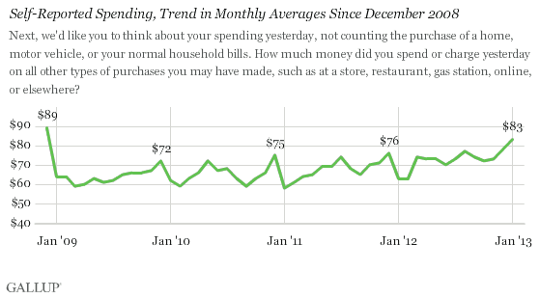
The December data are based on Gallup Daily tracking interviews with more than 13,000 U.S. adults conducted throughout the month.
In each of the last four years, December was the single month with the highest spending average, which is not surprising given the tradition of giving and receiving holiday gifts. The December averages are typically about $10 higher than the average of the prior 11 months combined.
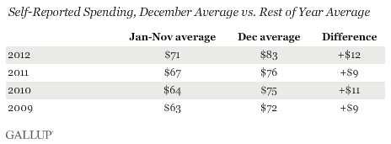
The four-year high in spending in December 2012 follows the trend toward increased spending Gallup has observed over the last four years. As the accompanying table shows, both the January through November and December averages have increased each year since 2009.
Spending Up Among Higher- and Lower-Income Americans
Typically, when Gallup finds variation in month-to-month spending, it is because of changes among the highest income Americans, those whose annual household incomes exceed $90,000. Americans below that income threshold have a more stable level of spending.
However, in December, self-reported spending increased among both income groups. The monthly average reported daily spending of $155 for higher-income Americans and $67 for lower-income Americans is the highest for each in at least four years.
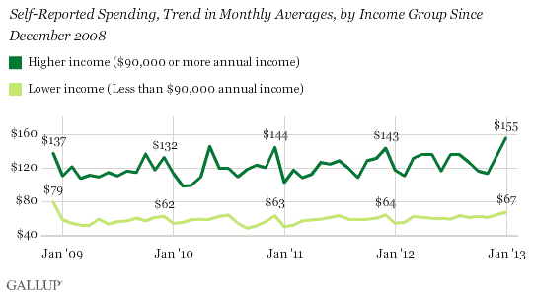
Thus, the increase in spending in December was broad-based, with people of varying economic resources spending at least a bit more than they have in recent memory.
Implications
The increase in Americans' reported spending is clearly a positive sign for the U.S. economy, which is heavily dependent on consumer spending to drive economic growth. Indeed, many retail stores reported strong sales in December after a slower start to the holiday season. And the 2012 holiday season proved to be a strong one for online retailers, something that Gallup's spending estimates would pick up but reports of sales at retail stores would not.
Whether the trend toward greater spending continues in 2013 is unclear. Most Americans are seeing a decrease in take-home pay with the expiration of the Social Security payroll tax holiday, but President Barack Obama's and Congress' efforts to avoid the fiscal cliff kept federal income tax rates the same for most Americans.
Whereas December is usually the strongest month for consumer spending, January is typically one of the weakest, so it is unlikely spending will remain at the higher level reached in December. One key to understanding the trend in consumer spending will be how January 2013 spending compares with prior Januaries. If January 2013 looks strong compared with prior Januaries, it is a sign that the economic momentum is continuing. If it is weaker, it could be a sign that Americans' more generous spending ways may be ending.
Survey Methods
Results are based on telephone interviews conducted as part of the Gallup Daily tracking survey Dec. 1-30, 2012, with a random sample of 13,217 adults, aged 18 and older, living in all 50 U.S. states and the District of Columbia, selected using random-digit-dial sampling.
For results based on the total sample of national adults, one can say with 95% confidence that the maximum margin of sampling error is ±1 percentage points.
The estimates for average daily spending have a margin of sampling error of ±$4.
Interviews are conducted with respondents on landline telephones and cellular phones, with interviews conducted in Spanish for respondents who are primarily Spanish-speaking. Each sample includes a minimum quota of 400 cellphone respondents and 600 landline respondents per 1,000 national adults, with additional minimum quotas among landline respondents by region. Landline telephone numbers are chosen at random among listed telephone numbers. Cellphone numbers are selected using random-digit-dial methods. Landline respondents are chosen at random within each household on the basis of which member had the most recent birthday.
Samples are weighted by gender, age, race, Hispanic ethnicity, education, region, adults in the household, population density, and phone status (cellphone only/landline only/both, cellphone mostly, and having an unlisted landline number). Demographic weighting targets are based on the March 2011 Current Population Survey figures for the aged 18 and older U.S. population. All reported margins of sampling error include the computed design effects for weighting.
In addition to sampling error, question wording and practical difficulties in conducting surveys can introduce error or bias into the findings of public opinion polls.
For more details on Gallup's polling methodology, visit http://www.gallup.com/.

GROUP 8:

December 5, 2012

Religion Big Factor for Americans Against Same-Sex Marriage

Overall, 53% favor legalized same-sex marriage, tying previous record high
by Frank Newport
PRINCETON, NJ -- Americans who oppose the legalization of same-sex marriage, 46% of the adult population, are most likely to explain their position on the basis of religious beliefs and/or interpretation of biblical passages dealing with same-sex relations.
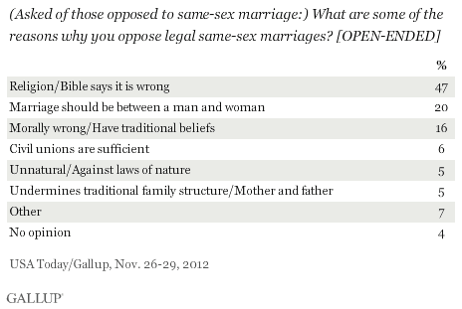
Other reasons given by those who oppose same-sex marriage include the conviction that marriage should be only between a man and a woman and the view that same-sex marriage is morally wrong or against traditional beliefs. Smaller percentages say that civil unions should be sufficient, that same-sex marriage is unnatural or against the laws of nature, or that same-sex marriage would undermine the traditional family structure.
These data are from a Nov. 26-29 USA Today/Gallup poll that explored a number of issues relating to the status of gays and lesbians in American society. Gallup.com will report additional findings later this week.
Supporters Cite Equal Rights and Personal Choice
Those who favor same-sex marriage are most likely to explain their position by saying either that it is a matter of equal rights, or that such things should be left to the personal choice of those involved. Other supporters say that it is not other people's business to decide who should get married, or that they personally know people who are gay or lesbian.
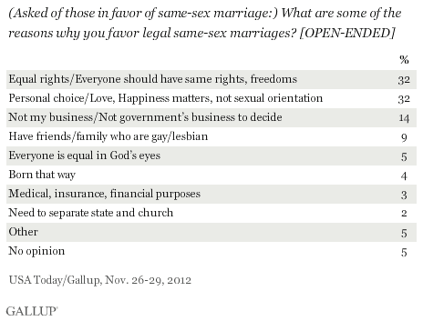
Fifty-Three Percent Favor Same-Sex Marriage; Ties Record High
Overall, 53% of Americans believe same-sex marriages should be recognized by law as valid, with the same rights as traditional marriages -- tying with May 2011 as the highest level of support Gallup has found since it began tracking the issue in 1996. Forty-six percent say such marriages should not be legal.
More than two-thirds of Americans were opposed to same-sex marriage in 1996 when Gallup first asked about the issue, and the majority were opposed as recently as 2010. But half or more of Americans have supported same-sex marriage in three out of the four Gallup surveys conducted since May 2011.
Young Americans, Democrats, and Those Who Don't Attend Church Most in Favor
Seven in 10 weekly church attenders are opposed to same-sex marriage, while seven in 10 of those who seldom or never attend church are in favor. This dramatic difference in position on same-sex marriage based on religiosity underscores the power of the relationship between religion and attitudes toward moral and values issues in America today.
The biggest differences by age in support for same-sex marriage occur at the extremes, with 34 percentage points separating 18- to 29-year-olds and those 65 and older. Support among Americans aged 30 to 64 is basically split, mirroring the national average.
Republicans are the most opposed to same-sex marriage, while Democrats are the most in favor. Independents tilt toward support -- close to the national average. This finding relates to the fact that party identification in the U.S. today is correlated with religiousness, with Republicans substantially more likely to be religious than independents or Democrats.
Implications
This survey confirms a significant change in American attitudes toward same-sex marriage -- with support rising to 53% today from 42% eight years ago and 27% in 1996. The issue is still divisive, however, particularly along age and political lines. Americans under the age of 30 and Democrats highly favor same-sex marriage, while those aged 65 and older and Republicans significantly oppose it.
These results also underscore the importance of religion as a correlate of these attitudes. A simple indicator of religiosity -- religious service attendance -- is a powerful predictor of views on same-sex marriage, with seven in 10 of those who attend weekly saying they are opposed, and seven in 10 of those who seldom or never attend saying they are in favor. Significantly, when asked to explain their position, almost half of those opposed to same-sex marriage focus on religion, including the statement that such a position follows the respondent's religious beliefs, or that it is based on their interpretation of the Bible.
Survey Methods
Results for this USA Today/Gallup poll are based on telephone interviews conducted Nov. 26-29, 2012, with a random sample of 1,015 adults, aged 18 and older, living in all 50 U.S. states and the District of Columbia.
For results based on the total sample of national adults, one can say with 95% confidence that the maximum margin of sampling error is ±4 percentage points.
Interviews are conducted with respondents on landline telephones and cellular phones, with interviews conducted in Spanish for respondents who are primarily Spanish-speaking. Each sample includes a minimum quota of 400 cellphone respondents and 600 landline respondents per 1,000 national adults, with additional minimum quotas among landline respondents by region. Landline telephone numbers are chosen at random among listed telephone numbers. Cellphone numbers are selected using random-digit-dial methods. Landline respondents are chosen at random within each household on the basis of which member had the most recent birthday.
Samples are weighted by gender, age, race, Hispanic ethnicity, education, region, adults in the household, population density, and phone status (cellphone only/landline only/both, cellphone mostly, and having an unlisted landline number). Demographic weighting targets are based on the March 2011 Current Population Survey figures for the aged 18 and older U.S. population. All reported margins of sampling error include the computed design effects for weighting.
In addition to sampling error, question wording and practical difficulties in conducting surveys can introduce error or bias into the findings of public opinion polls.
View methodology, full question results, and trend data.
For more details on Gallup's polling methodology, visit http://www.gallup.com/.

