STAT 1350: Elementary Statistics
Lab Activity #8 Name(s)_________________________
Descriptive Statistics - Graphs Date ___________________________

Never bitten, twice shy: the real dangers of summer.
The New York Times, 9 August, 2003, Op-ed
David Ropeik, Nigel Holmes
Risk expert David Ropeik and graphic designer Nigel Holmes have combined creative forces to describe the way that our emotional fears can cloud our reasonable perception of risk. "When asked in the abstract about the term 'risk', Americans correctly tend to talk in terms of statistical probability," the article states. "Yet when they are faced with specific threats, emotion overrules logic pretty quickly--we fear the unlikely and are relatively unconcerned about the truly dangerous." To illustrate this, the authors provide the following graphic:
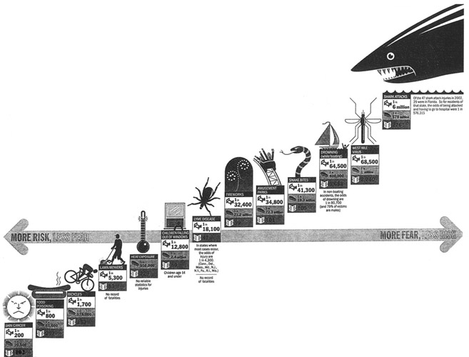
For each risk category (e.g., skin cancer, fireworks, west nile virus) there are three pieces of information: risk of injury and of death, and "fear index", as measured by the number of news stories about the topic written last summer. While the companion graphic employs some clever ways to visually present these ideas, it unfortunately has (at least) two logical problems.
First, the graphic presents the information along a line, implying a linear relationship that doesn't exist. While in several cases it is true that high risk activities have a fairly low fear index, and low risk activities have a high fear index, the relationship is by no means linear. The horizontal axis that reads on the left "More risk, less fear" and on the right, "More fear, less risk" only reinforces this misconception.
Second, while the risks decrease from left to right (which agrees with the horizontal axis labels), the risk categories themselves are "plotted" as a line that rises from left to right. Meanwhile except for the extreme "drowning" and "west nile virus" categories, the fear index is comparatively flat and not in any particular order.
Here is the information in the graphic provided by an old-fashioned table.
Risk | Odds of injury requiring medical treatment. (Bed) | Odds of dying (coffin) | Fear:Number of newspaper articles written last summer (newspaper)
skin cancer | 1 in 200 | 1 in 29,500 | 102
food poisoning | 1 in 800 | 1 in 55,600 | 257
Bicycles | 1 in 1,700 | 1 in 578,00 | 233
lawn mowers | 1 in 5,300 | not available | 53
heat exposure | not available | 1 in 950,000 | 229
children falling out of windows | 1 in 12,800 | 1 in 2.4 million | 89
lyme disease | 1 in 18,100 | not available | 47
Fireworks | 1 in 32,000 | 1 in 71.2 million | 59
amusement parks | 1 in 34,800 | 1 in 71.3 million | 101
snake bites | 1 in 25,300 | 1 in 19.3 million | 109
drowning (while boating) | 1 in 64,500 | 1 in 400,000 | 1,688
west nile virus | 1 in 68,500 | 1 in 1 million | 2,240
shark attacks | 1 in 6 million | 1 in 578 million | 276
DISCUSSION QUESTIONS:
( 1) How is the “fear index” measures? (HINT: See table headings on previous page.)

(2) Do you think that the measurement for “fear index" is a valid measure? Explain why or why not.

(3) Using the measurement for “fear index” that is described in this article, approximate the fear index of terrorism. Explain why your value is reasonable.

(4) What do you like about the graphic display on page 1?

(5) What don’t you like about the graphic display on page 1?

(6) How would you improve the graphic display? (HINT: Compare the number of variables with the number of axes used in the graphic display on page 1.)

