MATH 107 Final Exam Review Key

Please note—only the final answers are provided here. However, you will be required to show ALL WORK on the final exam (where appropriate.)

1. a) b) $\left\{ π, \sqrt{3}\right\}$ c)

2. a) i) {x | –3 < x ≤ 7} ii) iii) (– 3, 7]

–3 7

b) i) {x | x ≥ 5} ii) iii) [5, ∞)

5 ∞
3. a) – 3 b) –14 c)

4. a) (– b + ( b ² – 4 a c ) ) / ( 2 a ) b) 2.02

5. a) b) c) no solution d) all real numbers

6. or

7. a) $1513.43 b) $1528.16

8. length = 20 feet, width = 12 feet

9. 22 nickels

10. $1979.17 in sales

11. 1059 CDs

12. old salary was $452.38

13. a)
Hours | 1 | 1.25 | 1.5 | 1.75 | 2 | 2.25 | 2.5 | 2.75 | 3
Mostly Vegetables | 6.25 | 7.81 | 9.38 | 10.94 | 12.50 | 14.06 | 15.63 | 17.19 | 18.75
Mostly Flowers | 8.25 | 10.31 | 12.38 | 14.44 | 16.50 | 18.56 | 20.63 | 22.69 | 24.75

b) $50

14. a) Yes, substitute –5 for x and – 4 for y and see that the two sides are equivalent.

b) Answers will vary. (0, – 2), (1, – 8/5), (5, 0), (10, 2) are four possible solutions.
15. $y=−\frac{5}{4}x+\frac{\text{40}}{3}$; slope = $−\frac{5}{4}$; y-intercept point = $\left(0, \frac{\text{40}}{3}\right)$

16. a) y = 3 b) x = 5

17. A line with no slope is a vertical line (the slope is undefined and does not exist).
A line with zero slope is horizontal.

18. Parallel lines have the same slope and perpendicular lines have slopes which are negative reciprocals.

19. y-intercept point = (0, 4); x-intercept point = (–2, 0)
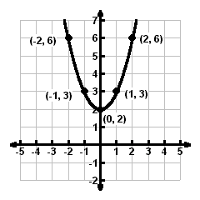
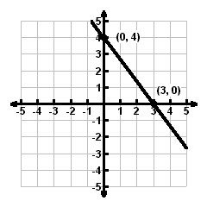
20. a) line b) parabola

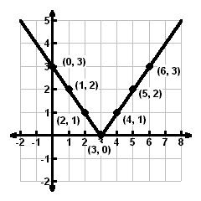
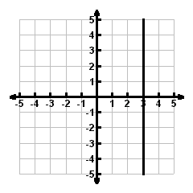
c) v-shaped d) line

21. a) domain = all real numbers OR $\left(−∞, ∞\right)$
range = {y | y ≥ –2} OR
function (justification based on definition will vary)

b) domain = {x | –2 ≤ x ≤ 4} OR [– 2, 4]
range = {y | 1 ≤ y ≤ 5} OR [1, 5]
not a function (justification based on definition will vary)

c) domain = {x | x ≤ 6} OR (– ∞, 6]
range = {y | y ≥ – 4} OR [– 4, ∞)
function (justification based on definition will vary)

22. domain = all real numbers OR $\left(−∞, ∞\right)$
range = {y | y ≥ –3} OR [– 3, ∞)
function (explanation will vary)

23. a) 0 b) – 45 c) –23.56

24. a) 0 b) –3 c) 0 d) 3 e) –3, 1, and 5
25. a) 0.65 b) 0 c) 0.35 d) f(x) = 0.35x + 1

26. a) (0, 500); 0 tables and 500 chairs could be manufactured in the available 1500 hours.
- (750, 0); 750 tables and 0 chairs could be manufactured in the available 1500 hours.
- If 50 tables are produced, then 466 chairs could be also be produced in the available 1500 hours.

27. a) If a salesperson sells $1000 of hardware in a week, then they will have a weekly salary of $400.
- $535
- $4500
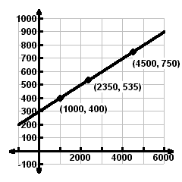
d)

e) [–1000, 6000, 1000] by [–100, 1000, 100] is one possible window

28. $y=−\frac{3}{4}x−5$

29. a) $y=−\frac{2}{3}x−\frac{\text{13}}{3}$ b) $y=\frac{3}{2}x$

30. $y=\frac{\text{65}}{4}x+\text{130}$ where x is the number of years since 2003 and y is the deposits in millions of dollars;
$308.75 million

31. a) y = 3.008x – 8.012
b) The predicted average top ticket price for 2013 is $121.32 per ticket.
c) The cost per ticket is increasing $3.01 per year.

32. a) b) $\left(−∞, −\frac{\text{18}}{\text{17}}\right)$

33. at most 3 hours
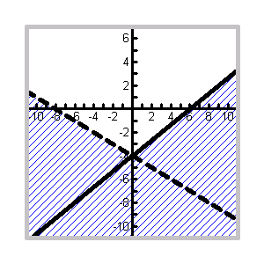
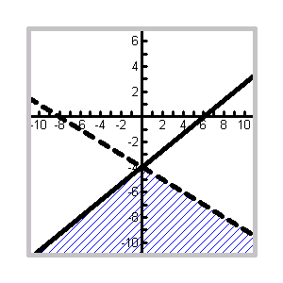

34. a) b)

35. a) $[−\text{11}\text{, }\frac{\text{23}}{2})$ b) $\left(\frac{1}{4}, 4\right)$

36. a) $\left[−5, 7\right]$ b) $(−∞, −4] ∪ [3, ∞)$ c) ∅ d) $\left(−∞, ∞\right)$
37. a) $\left[−\frac{\text{11}}{3}, \frac{\text{19}}{3}\right]$ b) $\left(\frac{1}{3}, \frac{7}{3}\right)$ c) $x=−\frac{1}{3}$ or $x=−3$ d) $\left(−∞, −1\right)∪\left(\frac{\text{11}}{5}, ∞\right)$ e) $\left(−∞, ∞\right)$ f) ∅

38. ( – ∞,– 4] [1, ∞)

39. (– 2.92, –12.75)
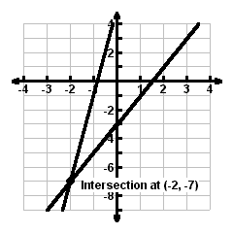
40. solution = (–2, –7)

41. a) (8, 3) b) $\left(\frac{5}{6}, \frac{1}{3}\right)$

42. a) Both variables drop out and the resulting numerical equation is false.
- Both variables drop out and the resulting numerical equation is true.

43. 20 liters of the 10% solution and 30 liters of the 60% solution
if x = the number of liters of 10% solution and y = the number of liters of 60% solution ,

then system of equations is $\begin{aligned}\left\{ x+y=\text{50} | \right.\end{aligned}$

44. 450 mph is the rate of the plane in calm air, 30 mph is the rate of the wind
if a = speed of the airplane in calm air and w = speed of the wind,

then the system of equations is $\begin{aligned}\left\{ 7\left(a+w\right)=\text{3360} | \right.\end{aligned}$

45. a) 5 b) $−\text{48}x^{6}y^{\text{13}}$ c) d) e)

46.

47.

48. 0.00031

49.

50. 5.7 seconds

51. ; degree 4

52. a) b) c) d) e)

