MATH 110 Final Exam Review Key

Please note—only the final answers are provided here. However, you will be required to show ALL WORK on the final exam (where appropriate.)

1. a) $\left(3x+1\right)\left(x−3\right)$ b) $2x^{2}\left(x−6\right)\left(x+6\right)$ c) $\left(x−2\right)\left(x^{2}+2x+4\right)$ d) $\left(x+6\right)\left(x−7\right)$

e) $\left(3+x\right)\left(b+y\right)$ f) $\left(x−y^{2}\right)\left(2x−5y\right)$ g) $9x^{2}\left(x^{2}+4\right)$ h)

i) ${\left(6x−5\right)}^{2}$ j) $\left(3x+5y\right)\left(9x^{2}−\text{15}\text{xy}+\text{25}y^{2}\right)$ k)

l)

2. (x + 4)(x – 3)

3. a) x = 0, x = b) x = , x = 4 c) x = , x = d) x = 0, x = 3, x = –3

4. 9 cm. and 12 cm.

5. a) {x | x is a real number and x ≠ 4} OR (–∞, 4) (4, ∞)

b) OR

c) {x | x is a real number and x ≠ –2 and x ≠ 5} OR (–∞, –2) (–2, 5) (5, ∞)

d) all real numbers OR (– ∞, ∞)

6. 7. $−\left(x+6\right)\left(x−2\right)$ 8. 9. $\frac{1}{3x\left(x+1\right)}$

10. 11. 12. x² + 2x – 4 $− \frac{2}{x − 3}$

13. 2x² – 4x + 11 14. a) no solution b) a = – 3 c) x = – 5 15. $a = \frac{2b}{3b−4}$

16. The speed of the express bus is 42 mph and the speed of the local bus is 35 mph.

17. 9.9 miles

18. 7.2 hours

19. $\frac{1}{4}$
20. a) domain = $[−3, ∞)$, range = $[−2, ∞)$ b) domain = $\left(−∞, ∞\right)$, range = $\left(−∞, ∞\right)$
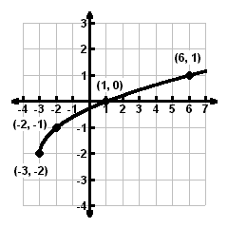
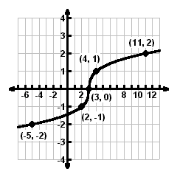

21. a) $\frac{3x^{\frac{\text{10}}{3}}}{y^{3}}$ b) $\frac{x^{4} \sqrt{x}}{8}$

22. a) $\text{13}\sqrt{5x}$ b) $6\sqrt{\text{15}}−2\sqrt{\text{30}}$

23. a) $\frac{\sqrt{\text{10}}}{4}$ b) $\frac{x+4\sqrt{x}−\text{21}}{x−9}$

24. Rational and Radical equations could have extraneous solution.
For rational equations, check to see if the solution obtained causes any of the denominators of the original
equation to be zero. If yes, then the solution is extraneous.
For radical equations, the potential solutions must be substituted into the original equation and the equality
should be tested numerically.
In both cases, a graphical check using the original equation would also serve to expose extraneous
solutions.

25. a) $−2+2i$ b) $6+2i$ c) $\text{24}+\text{10}i$

26. a) no solution b) x = 2

27. a) x = 0, $\frac{2}{3}$ b) $x=−1±\sqrt{5}$ c) $x=−\frac{1}{8} ± \frac{\sqrt{\text{143}}}{8}i$ d) x = 27, $−\frac{1}{8}$

e) $a=±2, ±\sqrt{3}$ f) $a=±2i, ±i\sqrt{3}$

28. exact: $\left(2+\sqrt{\text{46}}\right)$ feet approximate: 8.78 feet

29. 8.53 hours

30. $\left[−5, \frac{3}{2}\right] ∪ [4, ∞)$

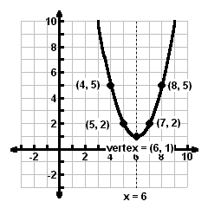
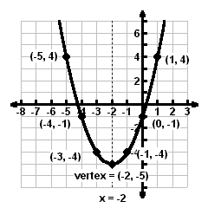
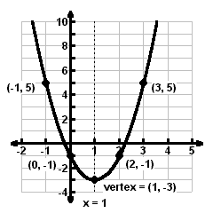
31. a) b) c)

32. a) $f(x)={\left(x−3\right)}^{2}+1$, vertex = (3, 1) b) $f(x)=−3{\left(x−1\right)}^{2}+7$, vertex = (1, 7)
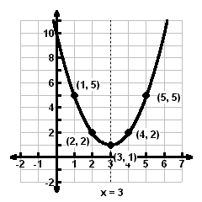
y-int. = $\left(0, \text{10}\right)$, no x-int. y-int. = $\left(0, 4\right)$, x-int. = $\frac{3±\sqrt{\text{21}}}{3}$
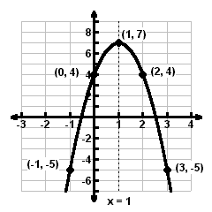

33. 3 seconds, 144 feet

34. a) quadratic b) $y= 0\text{.}\text{034}x^{2}−0\text{.}\text{563}x+\text{16}\text{.}\text{784}$ c) 18.26 births per thousand people

